 Exploring the Networks

Lab File

Submitted to

Amity University Uttar Pradesh

In partial fulfillment of the requirements for the award of the degree

of

Bachelor of Technology

in

Artificial Intelligence

by

**Manasi Chhibber**

**A023119819025**

Under the guidance of

Dr. Shipra Shukla

Assistant Professor

Department of Computer Science and Engineering

Amity School of Engineering and Technology

Amity University Uttar Pradesh

November 2021

Index

|  |  |  |  |  |  |  |  |  |  |
| --- | --- | --- | --- | --- | --- | --- | --- | --- | --- |
| **S.**  **No.** | **Category of Assignment** | **Code** | **Program**  **No.** | **Name of Program** | **Date of Allotment** | **Date of Submission** | **Max. Marks** | **Marks Obtained** | **Sig. of Faculty** |
| 1 | Mandatory Experiment | LR  (10) | 1 | Basic Networking Commands | 19/07/2021 | 19/07/2021 | 1 |  |  |
| 2 | 2 | Understanding Topologies | 26/07/2021 | 26/07/2021 | 1 |  |  |
| 3 | 3 | Configuring Switch | 02/08/2021 | 02/08/2021 | 1 |  |  |
| 4 | 4 | Configuring VLAN | 09/08/2021 | 09/08/2021 | 1 |  |  |
| 5 | 5 | Configuring Router | 20/09/2021 | 20/09/2021 | 1 |  |  |
| 6 | 6 | Configuring a Trunk Connection | 27/09/2021 | 27/09/2021 | 1 |  |  |
| 7 | 7 | Enabling Inter-VLAN Communication | 27/09/2021 | 27/09/2021 | 1 |  |  |
| 8 | 8 | Configuring Router with ipv6 Address | 04/10/2021 | 04/10/2021 | 1 |  |  |
| 9 | 9 | Configuring Servers | 11/10/2021 | 11/10/2021 | 1 |  |  |
| 10 | 10 | Static Routing with ip route Command | 25/10/2021 | 25/10/2021 | 1 |  |  |
| 11 | Performance | PR (10) |  |  |  |  | 10 |  |  |
| 12 | Viva | Viva (5) |  |  |  |  | 5 |  |  |

Experiment-1

**Aim:** To explore basic networking commands using command prompt.

**Tools and Technologies Used:** Windows Command Prompt

**Theory:**

1. **ipconfig:** ipconfig (standing for "Internet Protocol configuration") displays all current TCP/IP network configuration values and refreshes Dynamic Host Configuration Protocol (DHCP) and Domain Name System (DNS) settings.
2. **hostname:** This command displays the IP address of the remote machine.
3. **ping:** It is used to test the ability of the source computer to reach a specified destination computer.
4. **tracert:** It is used to show several details about the path that a packet takes from the computer or device you're on to whatever destination you specify.
5. **pathping:** It is used to locate spots that have network latency and network loss.
6. **arp -a:** The arp (address resolution protocol) command is used to view and manage the arp cache. The arp cache is a collection of IP and MAC addresses of devices on your local network that your computer knows about. -a is used for displaying all the entries.
7. **netstat:** The netstat command generates displays that show network status and protocol statistics.
8. **finger:** Finger command is a user information lookup command which gives details of all the users logged in.

**Practical:**

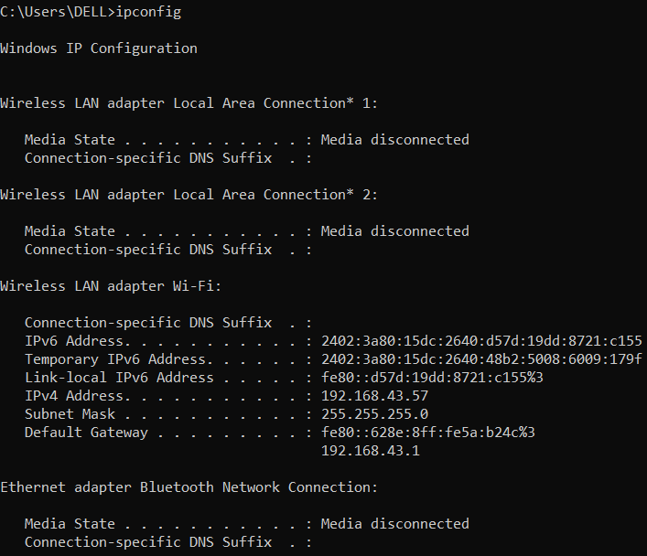



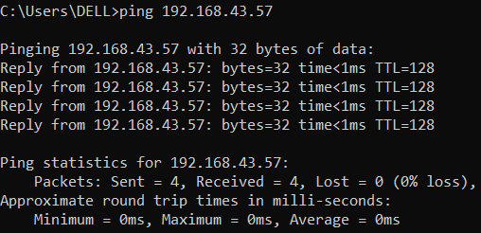

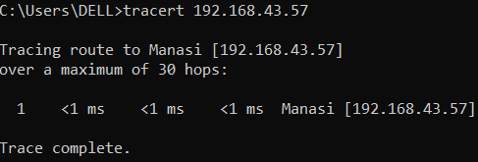

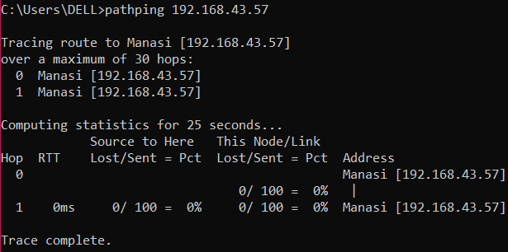

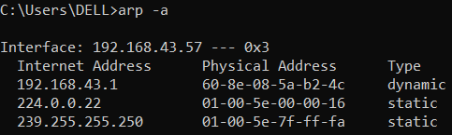

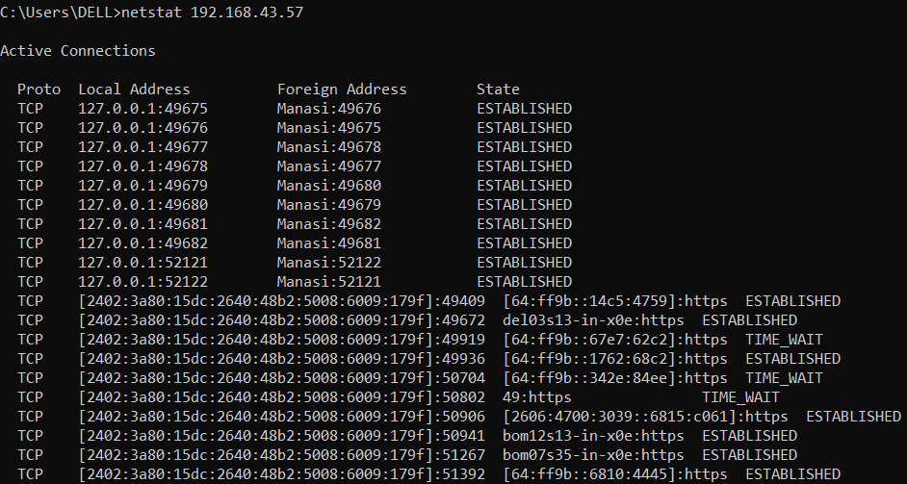

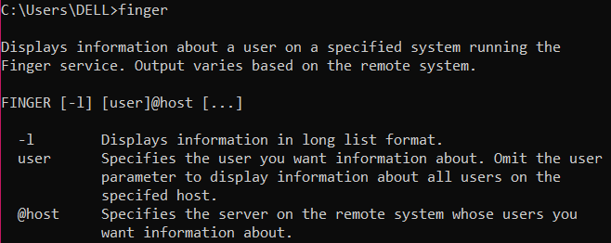

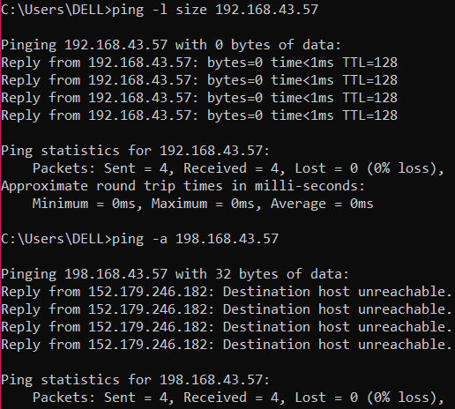

**Conclusion:** The experiment has been performed and all operations are correctly understood.

Experiment-2

**Aim:** To build various network topologies in Cisco Packet Tracer and configure all the devices.

**Tools and Technologies Used:** Cisco Packet Tracer

**Theory:**

1. **Cisco Packet Tracer:** Packet Tracer is a cross-platform visual simulation tool designed by Cisco Systems that allows users to create network topologies and imitate modern computer networks.
2. **Topology:** Topology defines the structure of the network of how all the components are interconnected to each other. There are two types of topologies: physical and logical topology. A logical topology is how devices appear connected to the user. A physical topology is how they are interconnected with wires and cables.
3. **ping:** It is used to test the ability of the source computer to reach a specified destination computer.

**Practical:**

A peer-to-peer network:

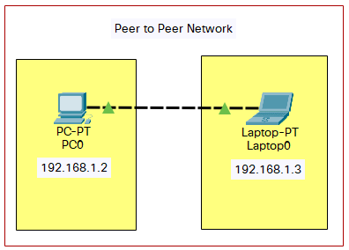

Method to configure the IP address of a device:

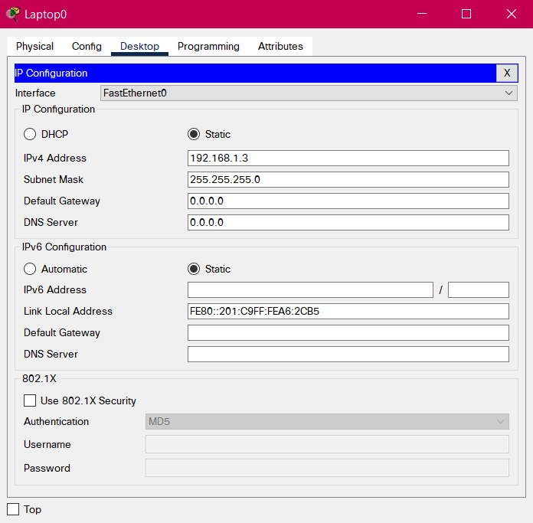

Performing ping to check the connection:

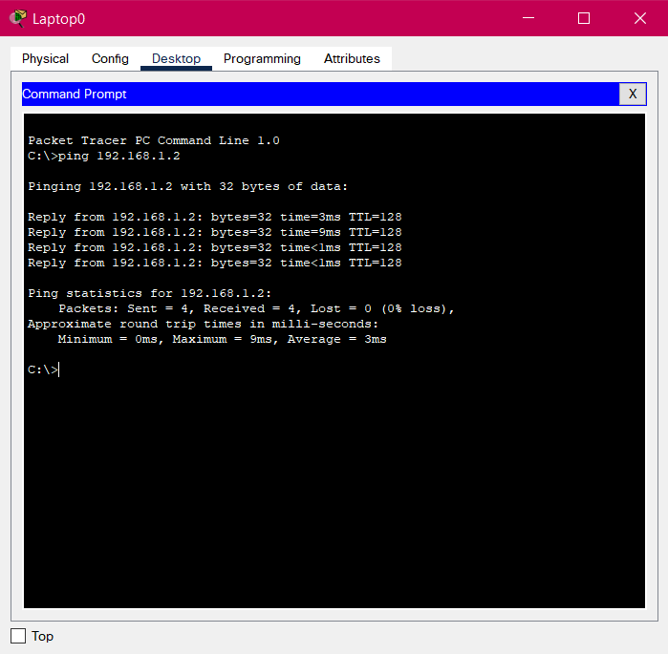

Forming various topologies, configuring the devices and pinging to check the connection:

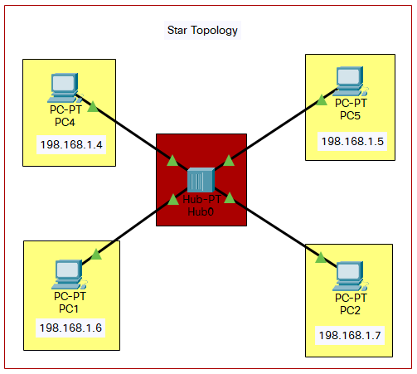

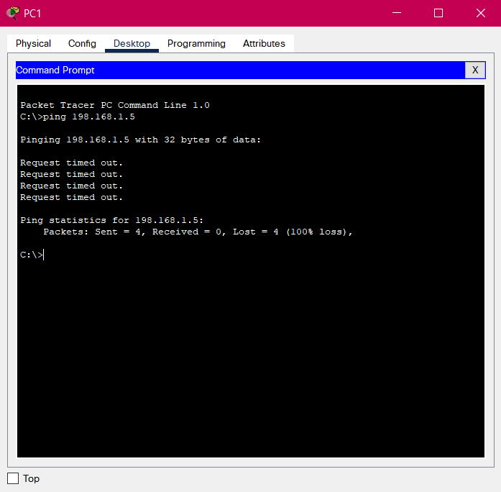

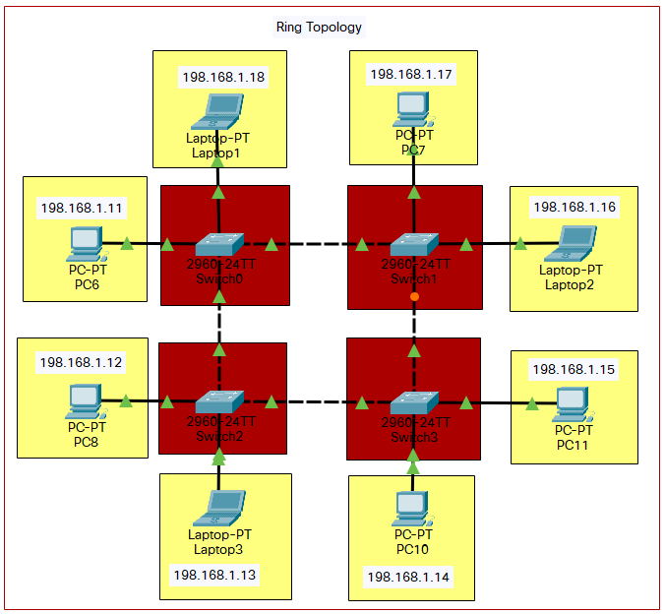

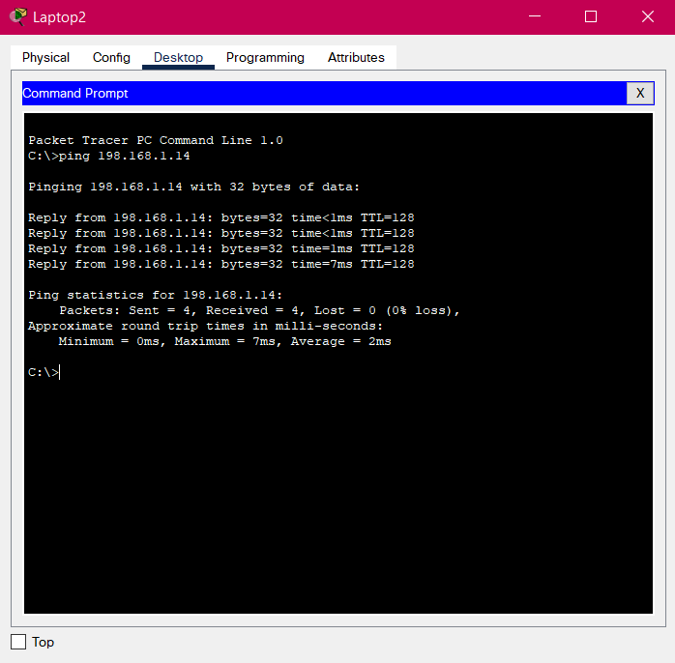

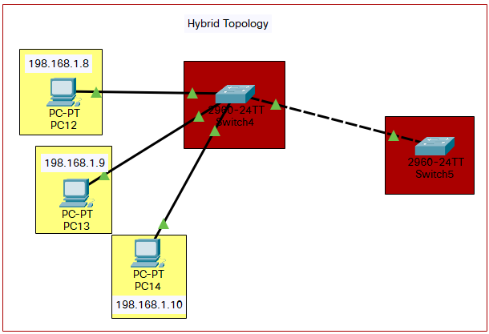

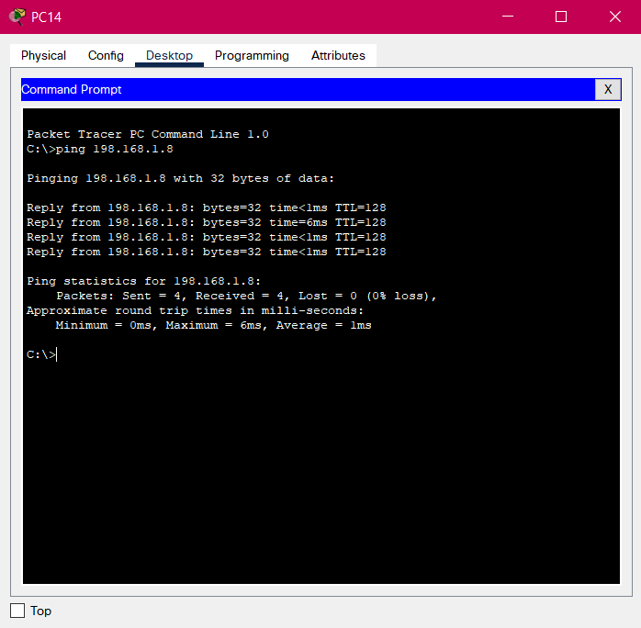

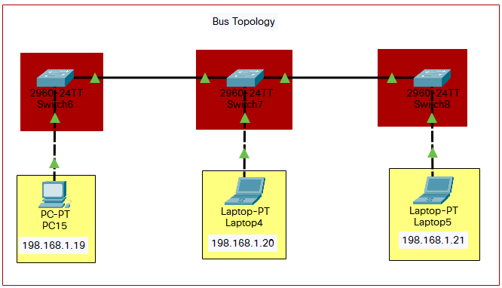

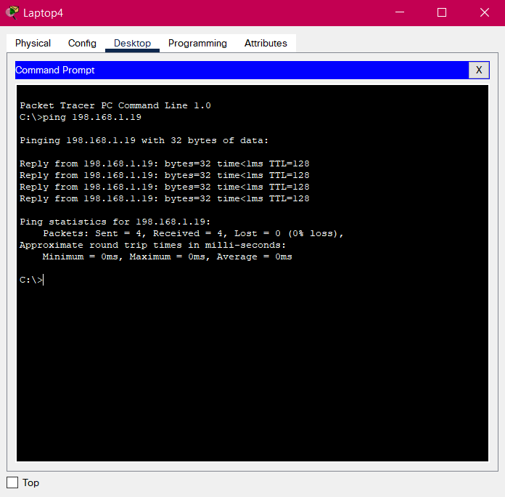

**Conclusion:** The experiment has been performed and all operations are correctly understood.

Experiment-3

**Aim:** To configure all switches.

**Tools and Technologies Used:** Cisco Packet Tracer

**Theory:**

1. **en:** Enable command to go from use execution mode to privileged execution mode.
2. **conf t:** To move to configuration mode.
3. **no ip domain-lookup:** Disables the IP DNS-based host name-to-address translation.
4. **interface fa0/1:** Interface configuration mode is used to configure a switch port or router interface. fa refers to fast ethernet. The command is used to move directly from one sub configuration mode to another mode.
5. **shutdown:** The shutdown command disables an interface.
6. **enable secret class:** To set a password.
7. **line con 0:** To move in and out of line configuration mode, this line command is used followed by the management line type.
8. **password:** To take the password from the user.+
9. **login:** To login using the password.
10. **exit:** To exit a configuration mode.
11. **hostname:** To rename a switch.
12. **interface vlan1:** vlan1 is the default VLAN. The switch is connected to the router through this VLAN. This can be used but cannot be modified or deleted. The command is used to interface with a virtual LAN.
13. **shutdown:** To shut down the local traffic on an interface.
14. **ip address:** To set the ip address for the switch.
15. **no shut:** no shutdown turns the interface on (enables it).
16. **end:** To end configuring the switch.
17. **copy run start:** To overwrite the current startup config file with what is currently in the running configuration file.
18. **line vty 0 15:** VTY lines are usually used for creating out-of-band management sessions to devices. If a password is not supplied on a vty line, that line cannot be used for managing the device. 0 15 specify the number of lines, here 16.
19. **service password-encryption:** This command obscures all clear-text passwords.
20. **banner motd #------#:** To display the content enclosed between the #s.
21. **show running-config:** The show running-config command shows the router, switch, or firewall's current configuration.

**Practical:**

Configuring a switch (Switch0) in ring topology:

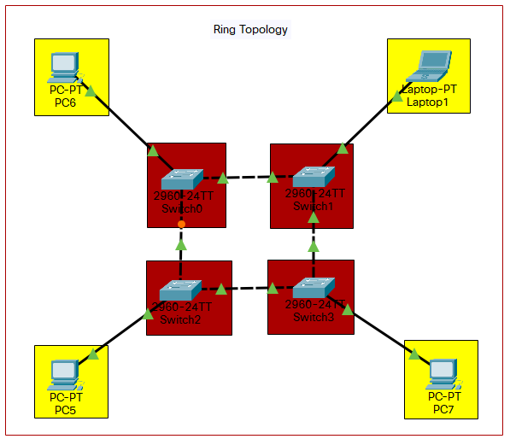

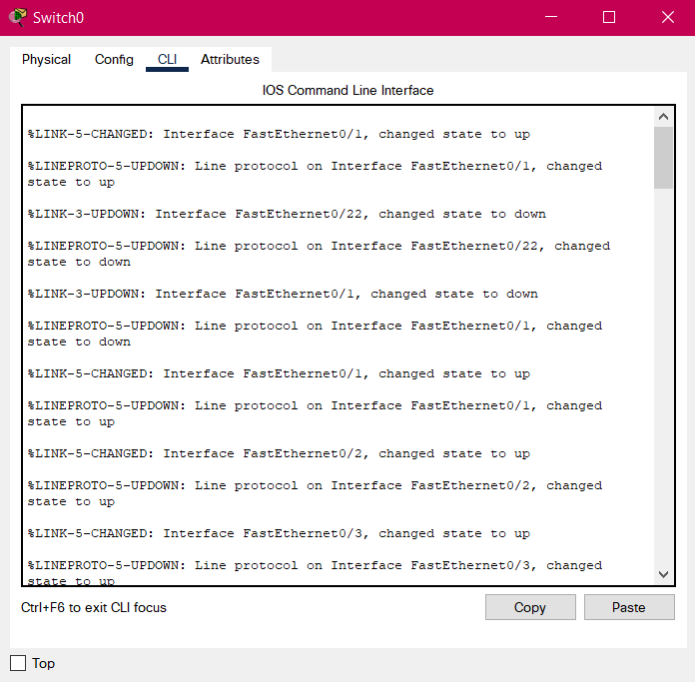

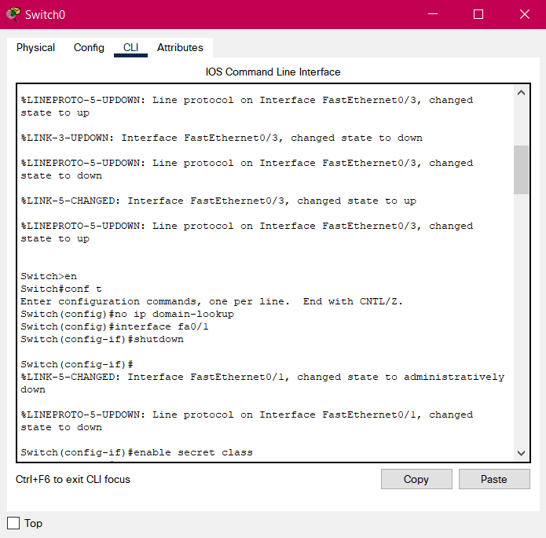

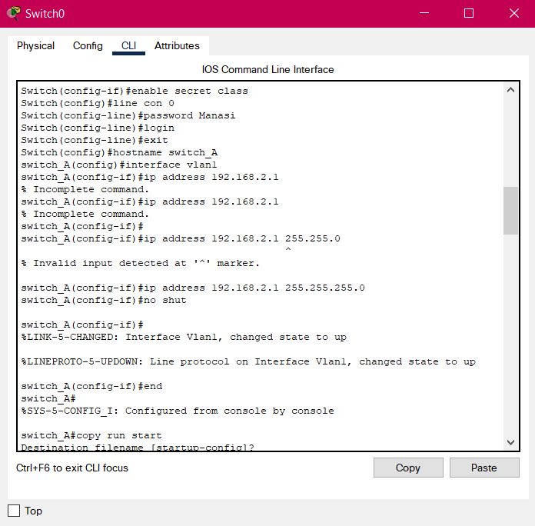

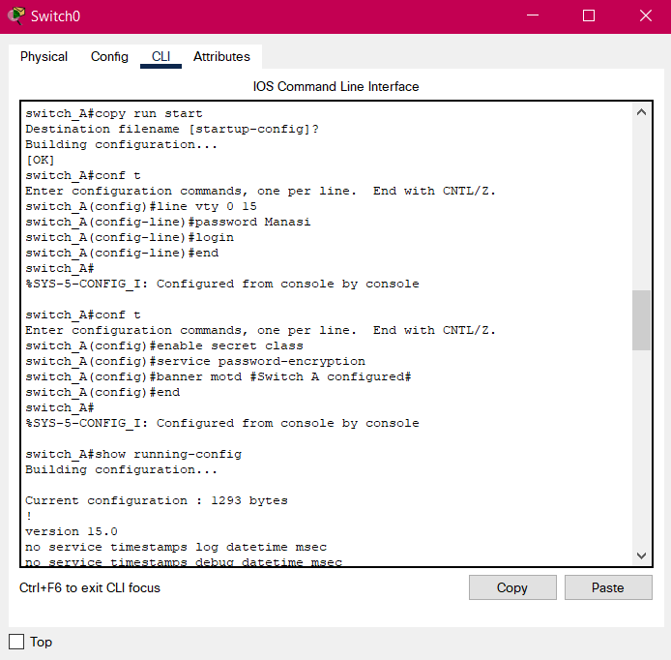

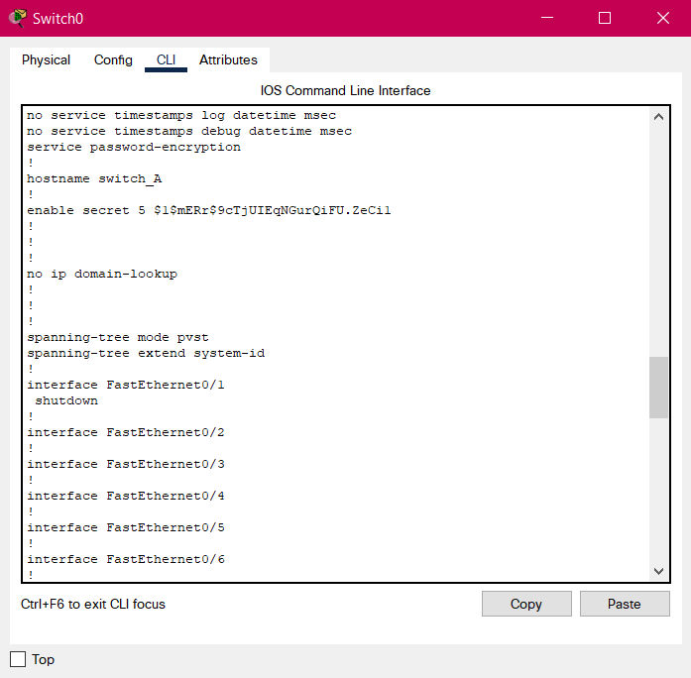

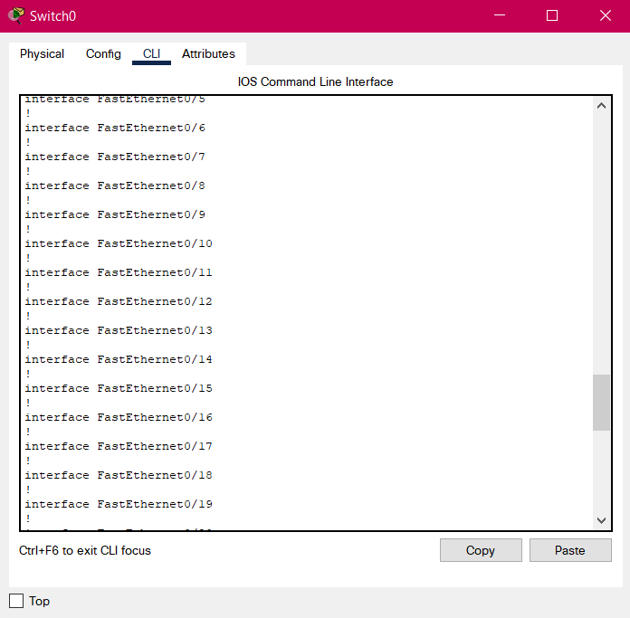

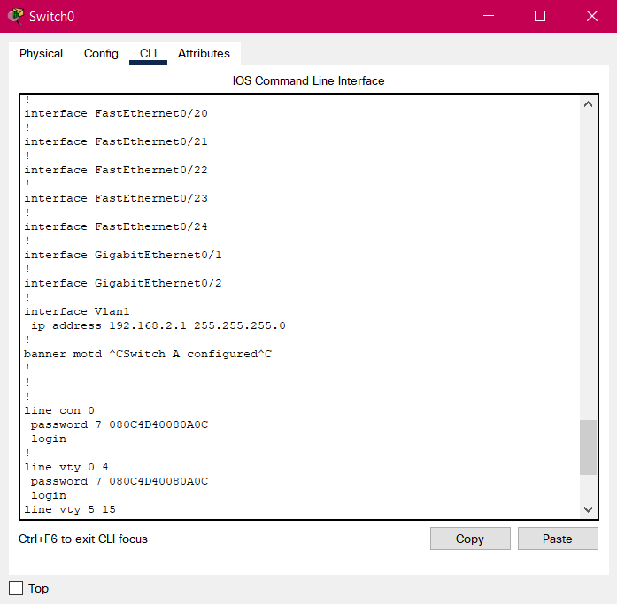

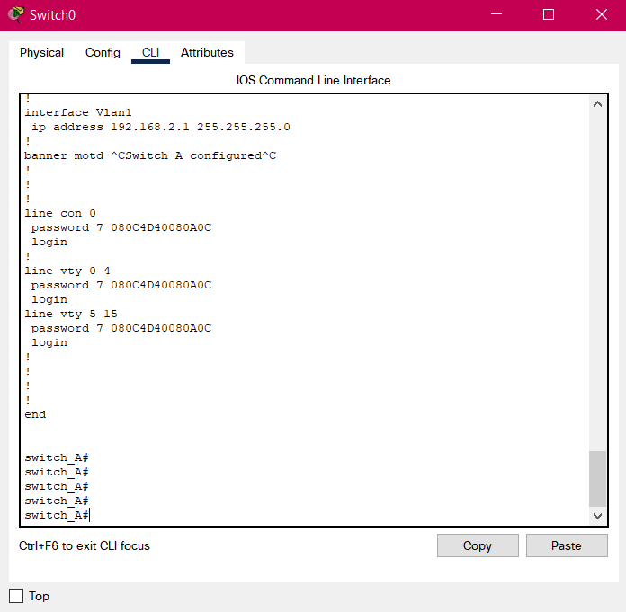

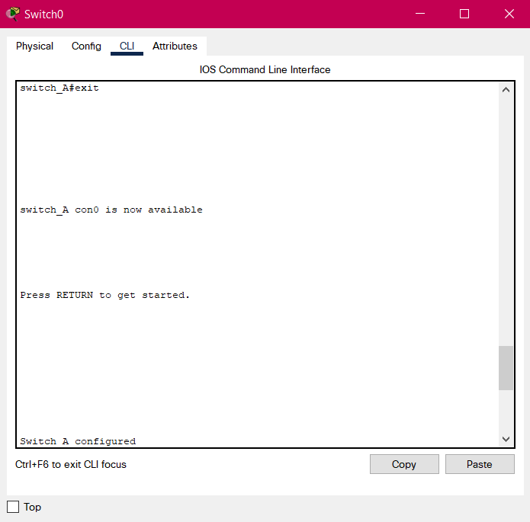

Similarly configuring Switch1, Switch2 and Switch3:

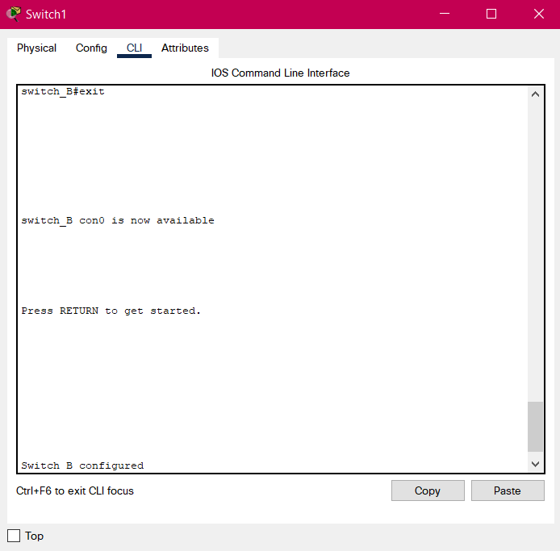

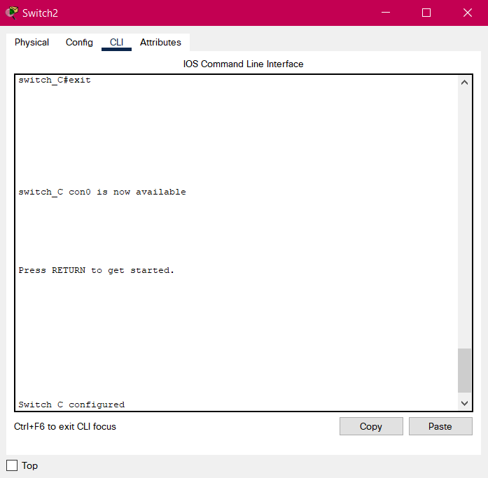

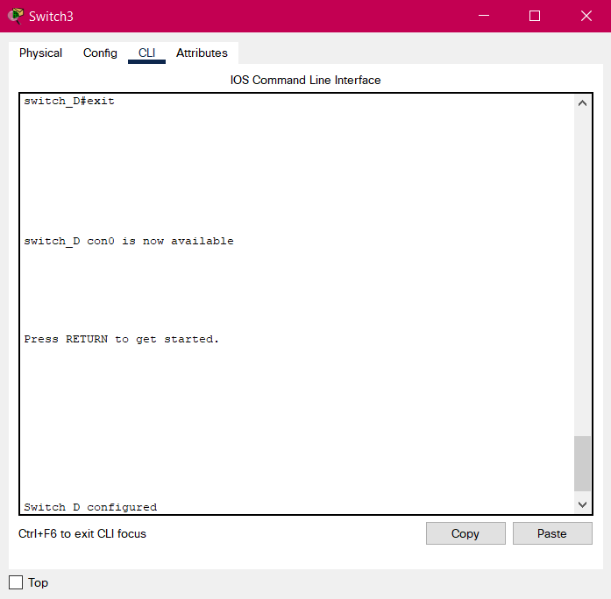

Configuring a switch in star topology:

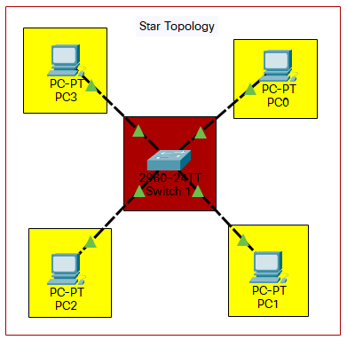

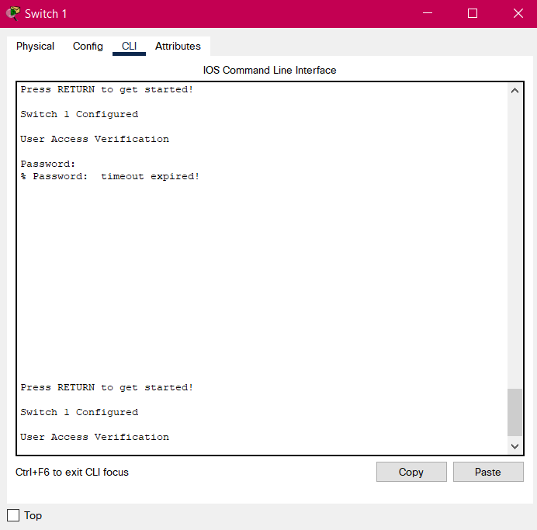

**Conclusion:** The experiment has been performed and all operations are correctly understood.

Experiment-4

**Aim:** To configure the switch with different VLANs.

**Tools and Technologies Used:** Cisco Packet Tracer

**Theory:**

VLANs allow network administrators to automatically limit access to a specified group of users by dividing workstations into different isolated LAN segments. Given below are the steps to setup multiple VLANs:

1. Go to the configuration mode using **en** and **conf t**.
2. Select a fast ethernet line for interfacing.
3. Choose VLAN number.
4. Provide VLAN a name.
5. Exit and go to step 2.

Once these steps are completed for all the ethernet lines, follow this:

1. Go to the configuration mode again.
2. Select any fast ethernet line for interfacing.
3. Type **switchport mode access** to enable the setup of VLAN.
4. Type **switchport access <VLAN’s number>** to allow access to a particular VLAN.
5. Exit and go to step 2.

Repeat this process for all ethernet lines. Now, the VLANs are setup and access to the devices gets restricted.

**Practical:**

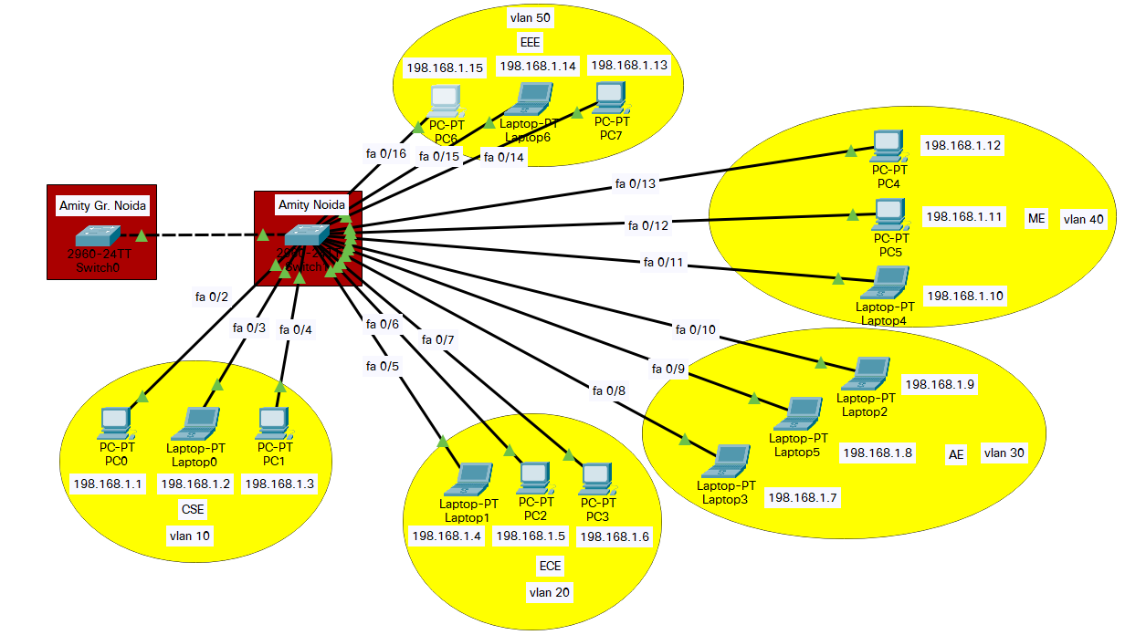

Before the VLANs were setup, any device could ping any other device, without restrictions:

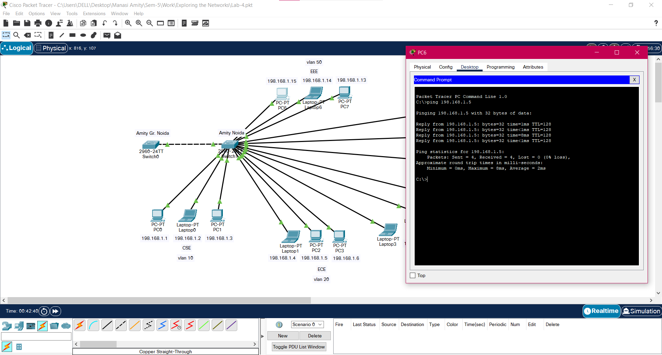

Setting up the VLANs:

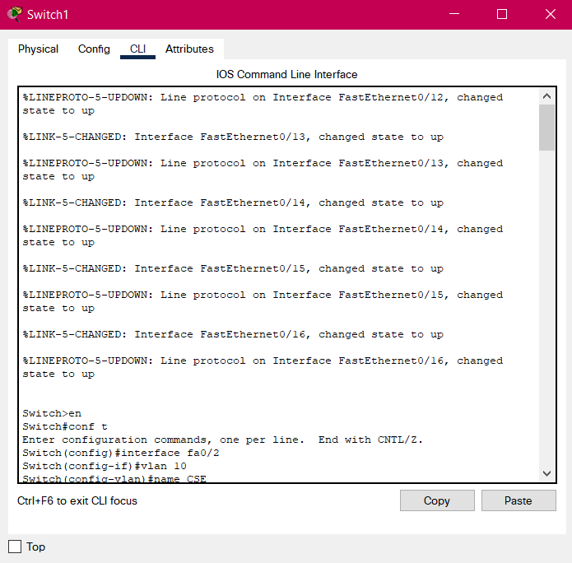

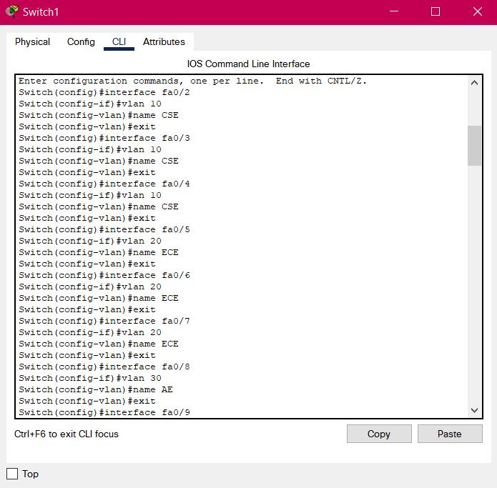

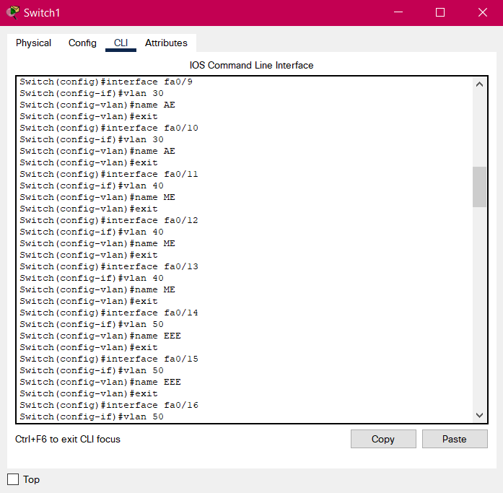

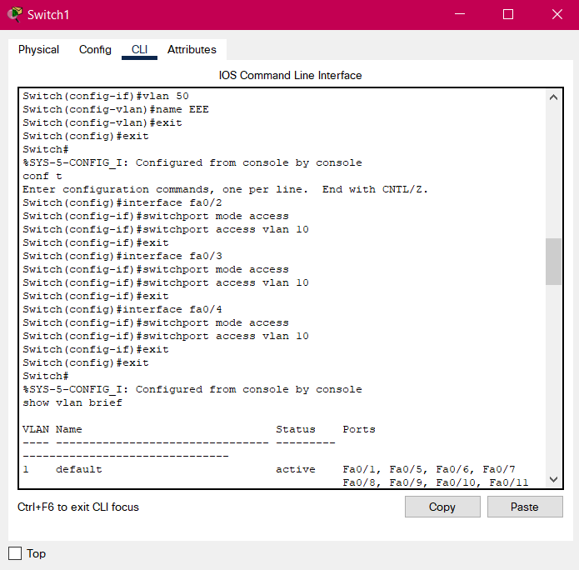

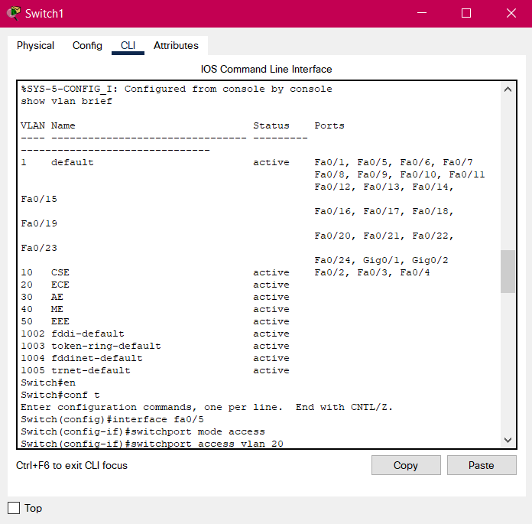

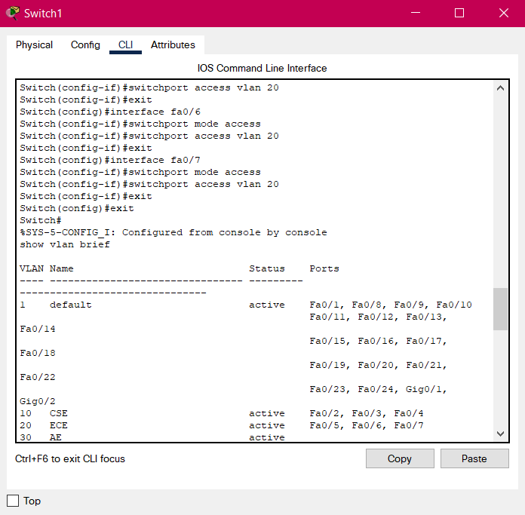

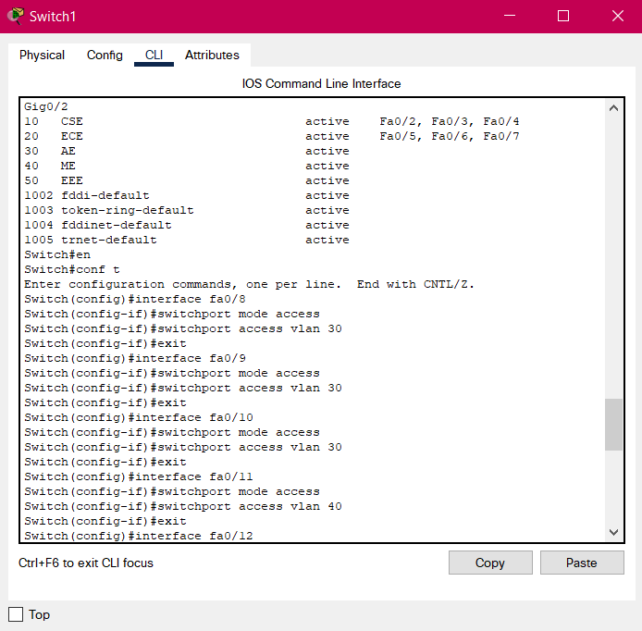

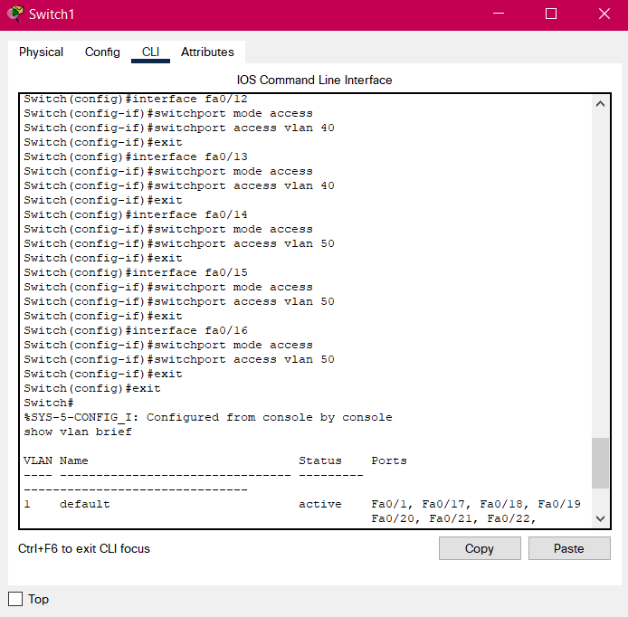

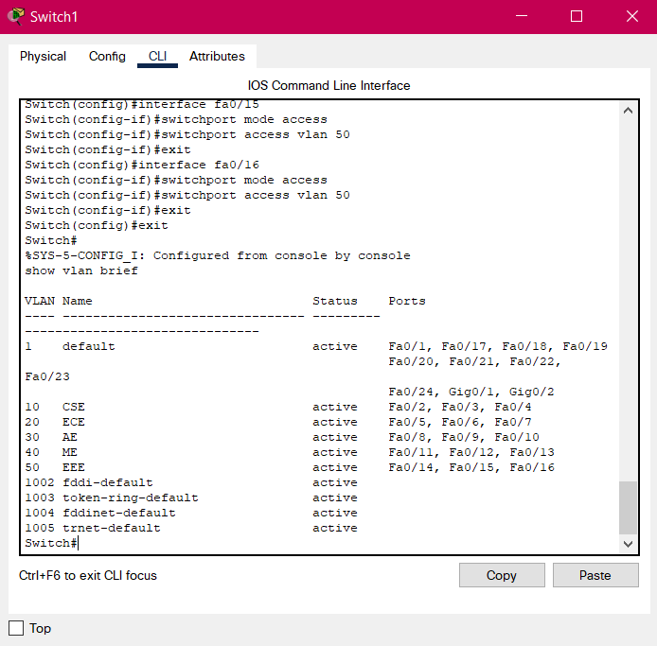

Once the setup is complete, the access gets restricted:

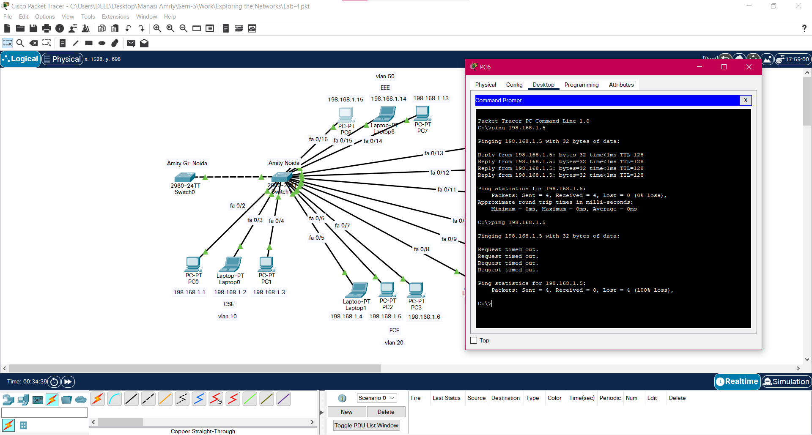

**Conclusion:** The experiment has been performed and all operations are correctly understood.

Experiment-5

**Aim:** To configure a router.

**Tools and Technologies Used:** Cisco Packet Tracer

**Theory:**

A router is a device that connects two or more packet-switched networks or subnetworks. It serves two primary functions: managing traffic between these networks by forwarding data packets to their intended IP addresses and allowing multiple devices to use the same Internet

connection.

Following are the commands which are used while configuring a router:

1. **en:** Enable command to go from use execution mode to privileged execution mode.
2. **conf t:** To move to configuration mode.
3. **hostname:** To rename the router.
4. **interface:** To select a particular interface and connect it.
5. **no shut:** no shutdown turns the interface on (enables it).
6. **interface loopback:** The loopback interface is used to identify the device. While any interface address can be used to determine if the device is online, the loopback address is the preferred method.

**Practical:**

**Conclusion:** The experiment has been performed and all operations are correctly understood.

Experiment-6

**Aim:** To configure a trunk connection.

**Tools and Technologies Used:** Cisco Packet Tracer

**Theory:**

Routers on stick: We channelize the link of router for incoming and outgoing for smooth transition of traffic from one path to another path so that there is no congestion. Network performance improves in terms of throughput, delay, and latency.

Following are the commands which are used while configuring a router on stick:

1. **en:** Enable command to go from use execution mode to privileged execution mode.
2. **conf t:** To move to configuration mode.
3. **int g0/0/0:** To go to a particular interface and configure it.
4. **no ip address:** To skip assigning an ip address.
5. **no shut:** no shutdown turns the interface on (enables it).
6. **exit:** To exit a configuration mode.
7. **sh ip inference brief:** To show the details of the configuration of all the interfaces.

**Practical:**

**Conclusion:** The experiment has been performed and all operations are correctly understood.

Experiment-7

**Aim:** To enable inter-VLAN communication.

**Tools and Technologies Used:** Cisco Packet Tracer

**Theory:**

VLANs allow network administrators to automatically limit access to a specified group of users by dividing workstations into different isolated LAN segments. Inter-VLAN routing is the process of forwarding network traffic from one VLAN to another VLAN.

Following are the commands which are used while enabling inter-VLAN communication:

1. **en:** Enable command to go from use execution mode to privileged execution mode.
2. **conf t:** To move to configuration mode.
3. **int g0/0/0:** To go to a particular interface and configure it.
4. **switchport mode access:** To enable the setup of VLAN.
5. **no shut:** no shutdown turns the interface on (enables it).
6. **exit:** To exit a configuration mode.

**Practical:**

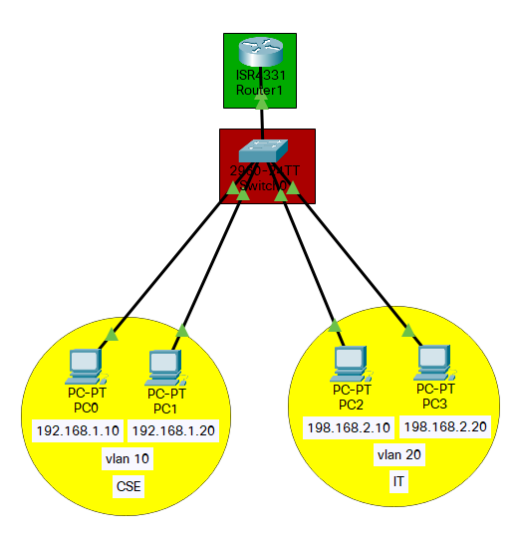

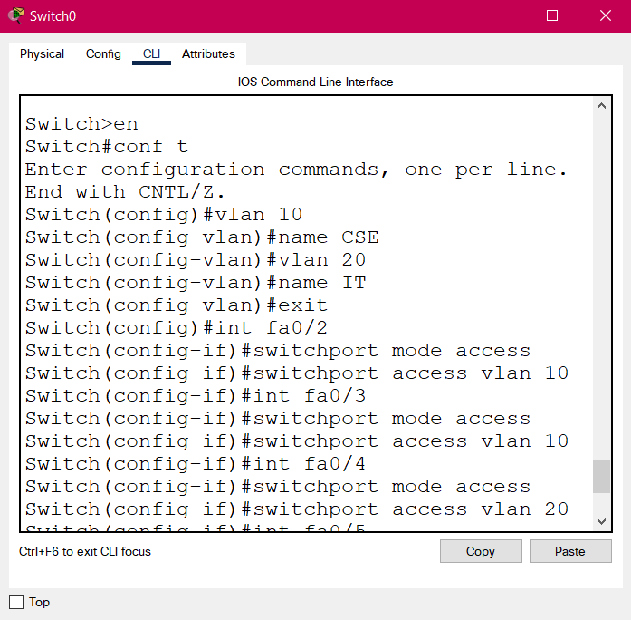

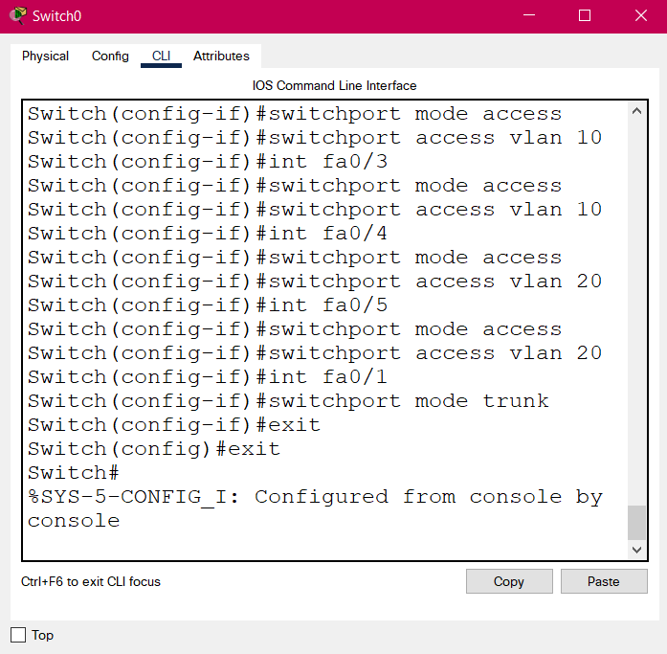

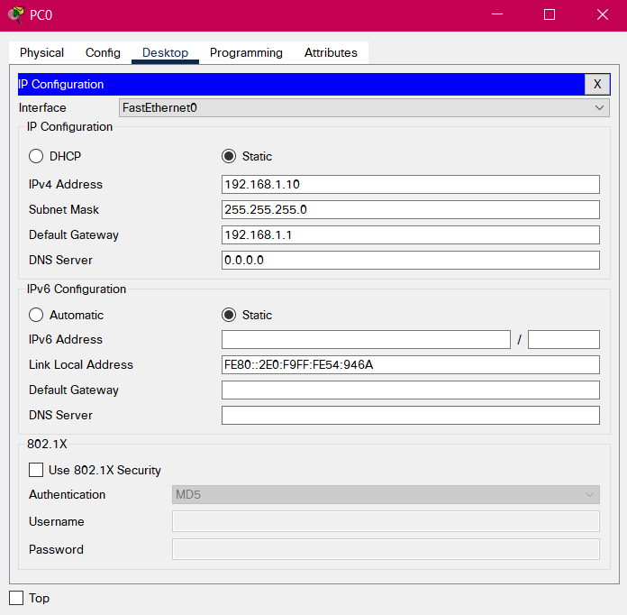

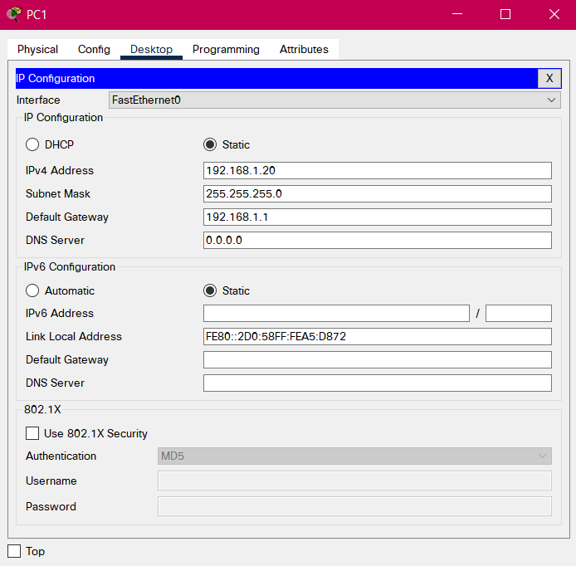

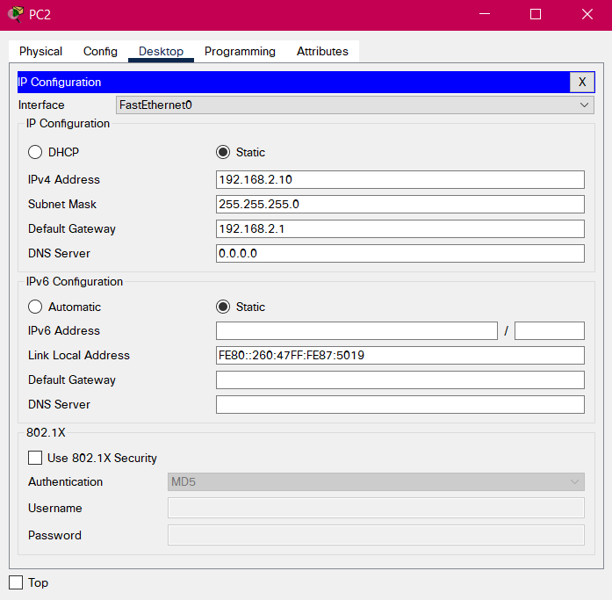

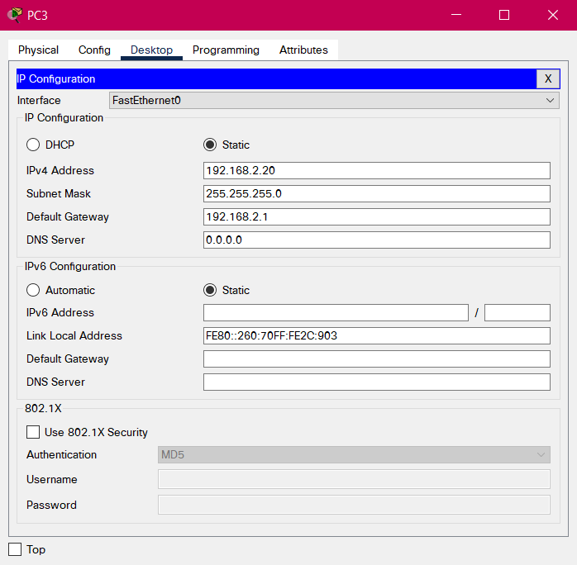

Before enabling communication:

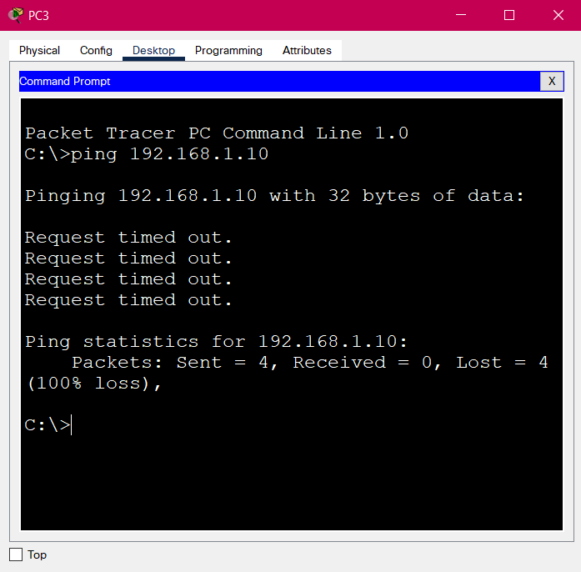

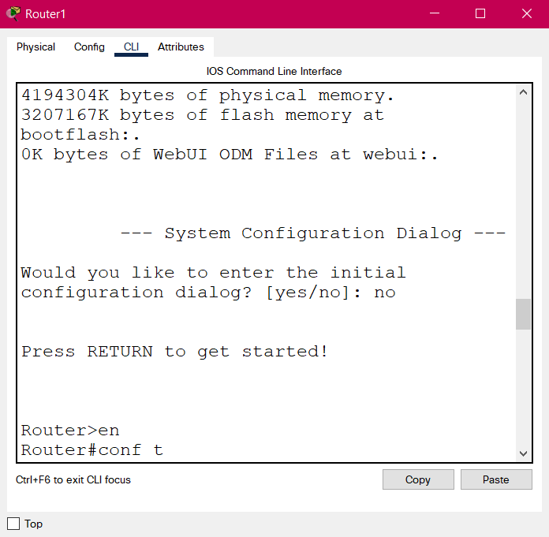

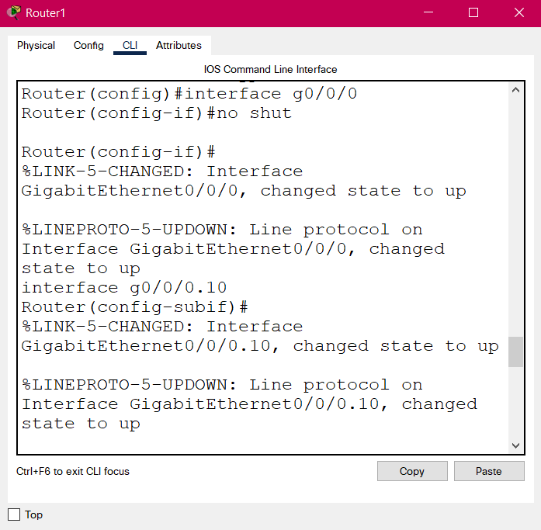

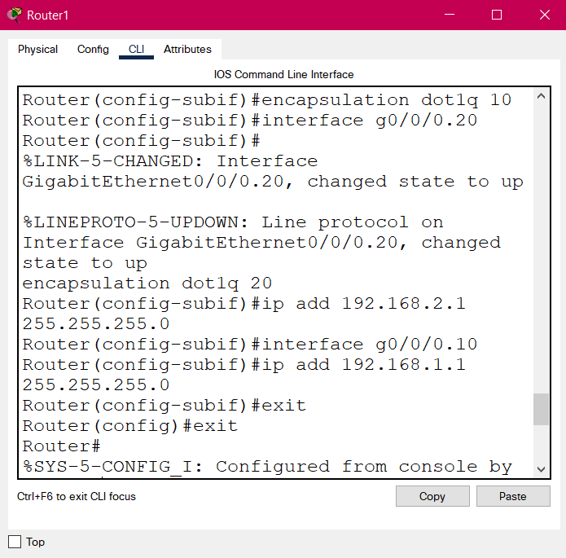

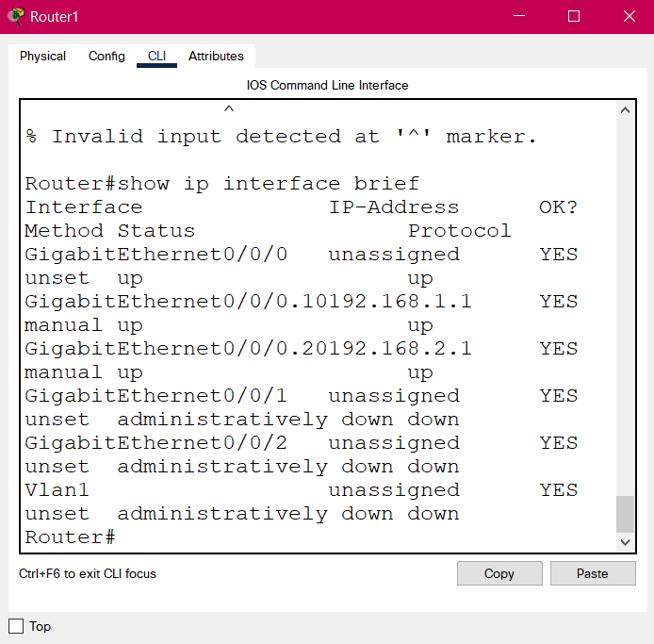

After enabling communication:

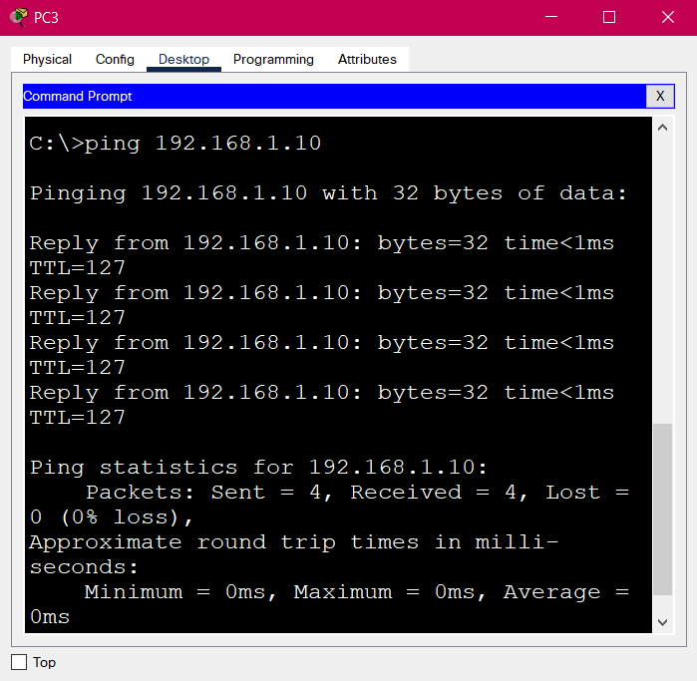

**Conclusion:** The experiment has been performed and all operations are correctly understood.

Experiment-8

**Aim:** To configure a router with ipv6 address.

**Tools and Technologies Used:** Cisco Packet Tracer

**Theory:**

The main differences between ipv4 and ipv6 address are given below:

|  |  |
| --- | --- |
| **Ipv4 Address** | **Ipv6 Address** |
| 32-bit address length | 128-bit address length |
| It can generate 4.29×109 address space. | Address space of IPv6 is quite large it can produce 3.4×1038 address space. |
| In IPv4 checksum field is available. | In IPv6 checksum field is not available. |
| It has broadcast Message Transmission Scheme. | In IPv6 multicast and any cast message transmission scheme is available. |
| IPv4 has header of 20-60 bytes. | IPv6 has header of 40 bytes fixed. |

Following are the commands which are used while configuring a router with ipv6 address:

1. **en:** Enable command to go from use execution mode to privileged execution mode.
2. **conf t:** To move to configuration mode.
3. **interface:** To select a particular interface and connect it.
4. **ipv6 address:** To assign an ipv6 address.
5. **no shut:** no shutdown turns the interface on (enables it).
6. **exit:** To exit a configuration mode.
7. **show inference:** To show all the details of the configuration.

**Practical:**

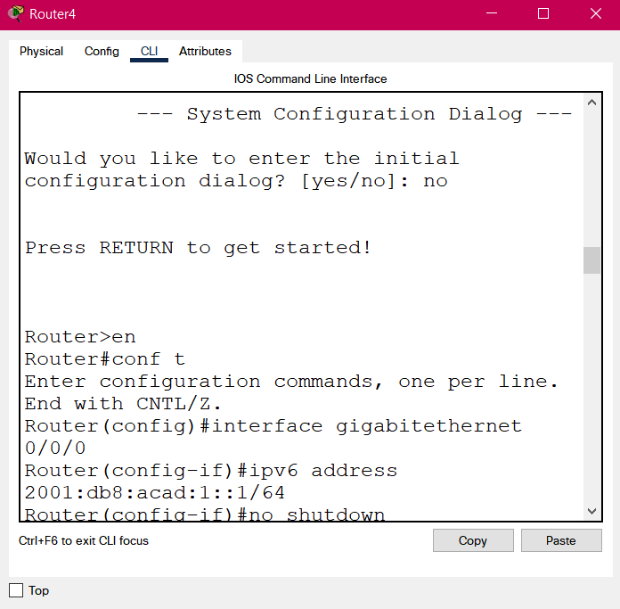

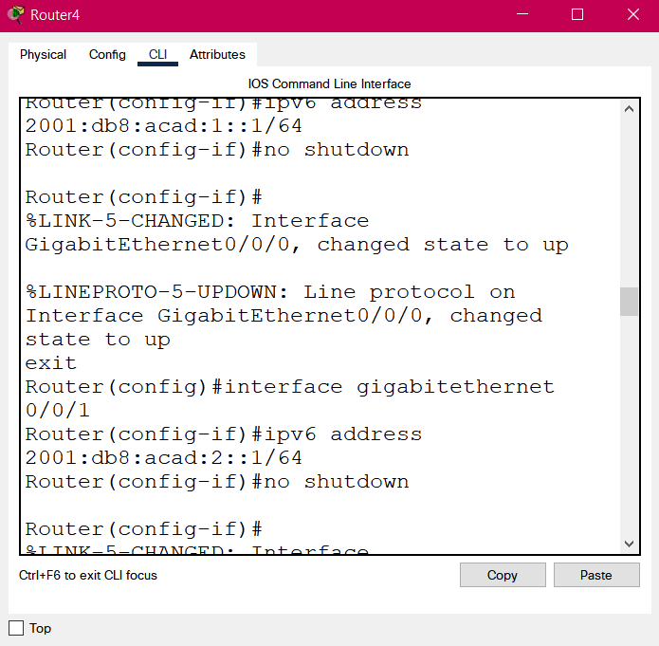

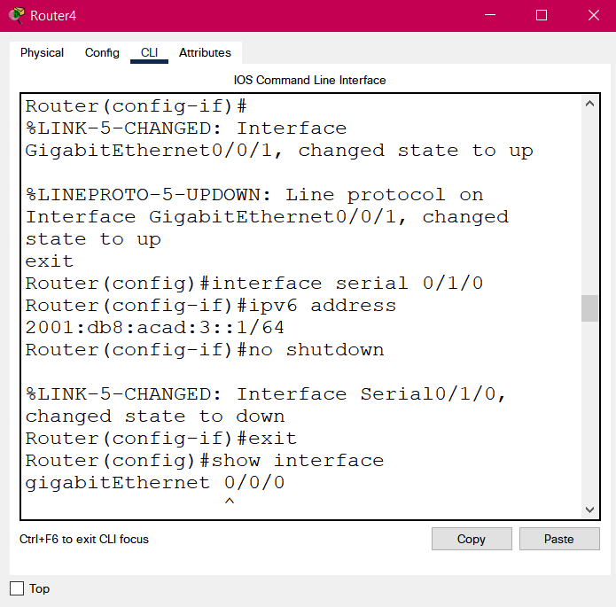

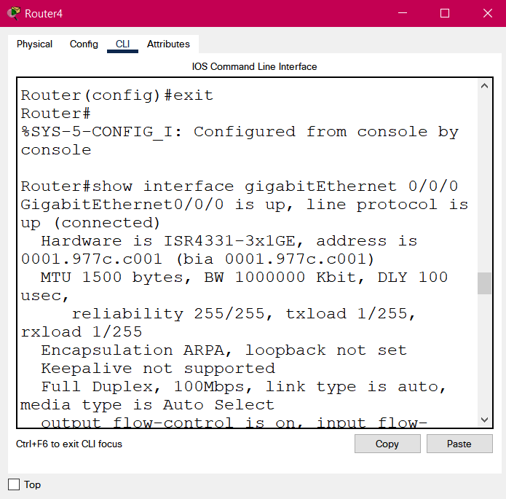

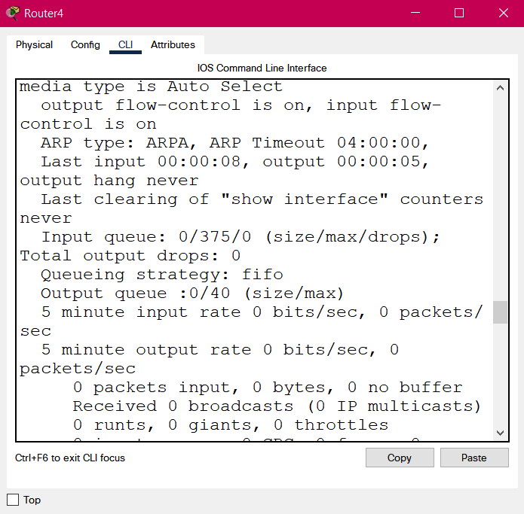

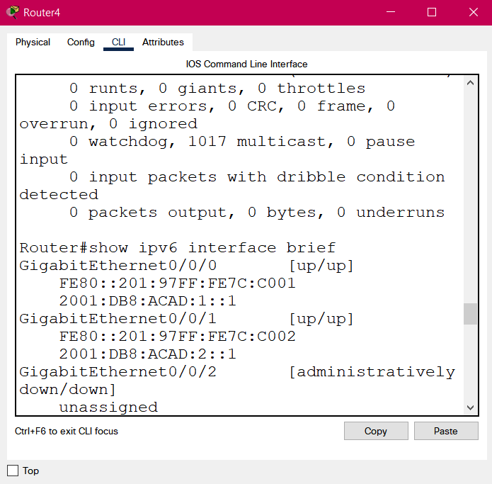

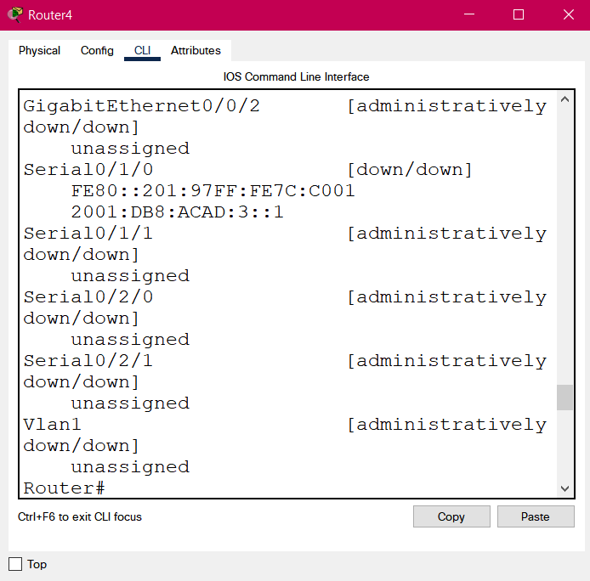

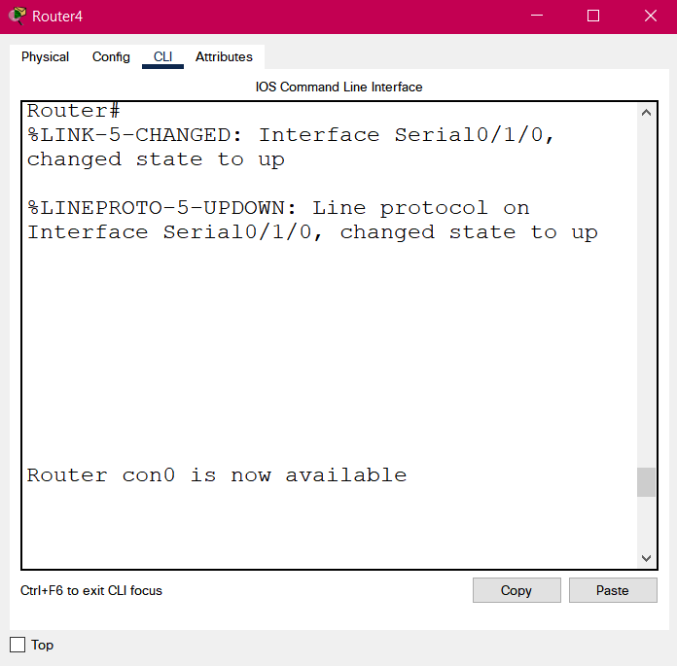

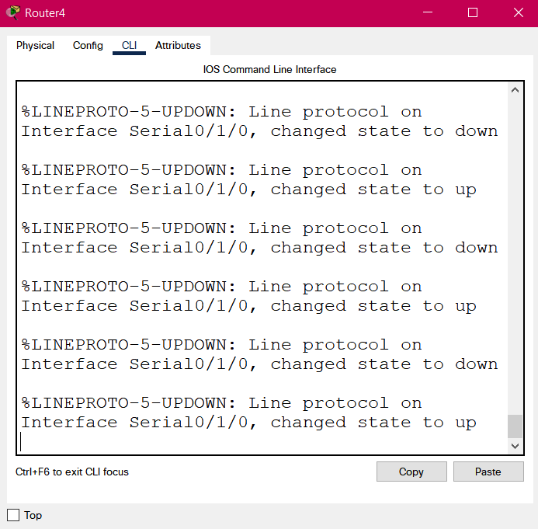

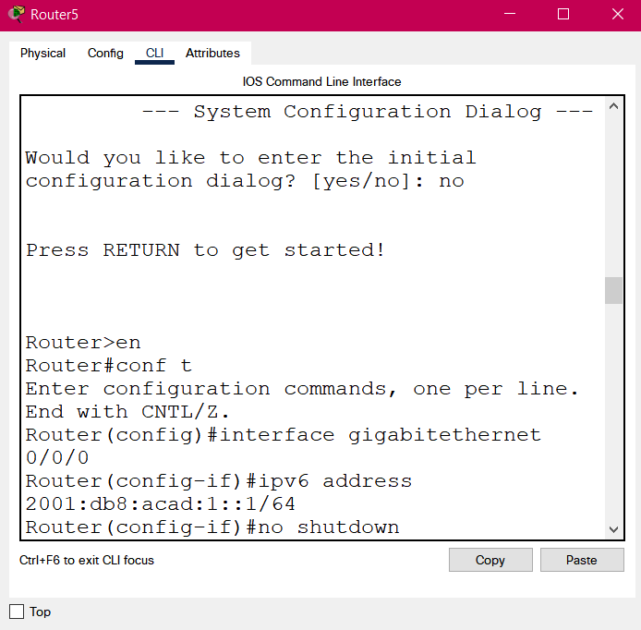

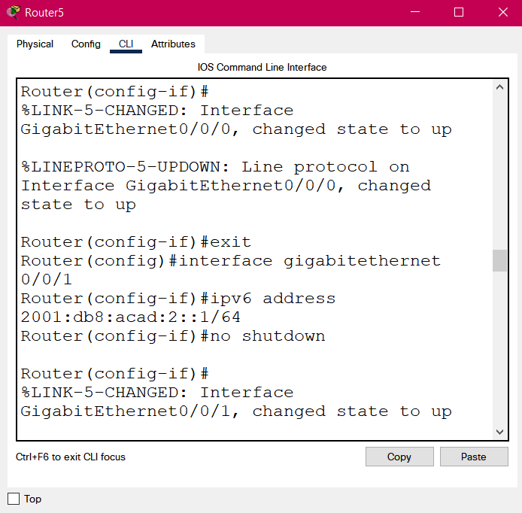

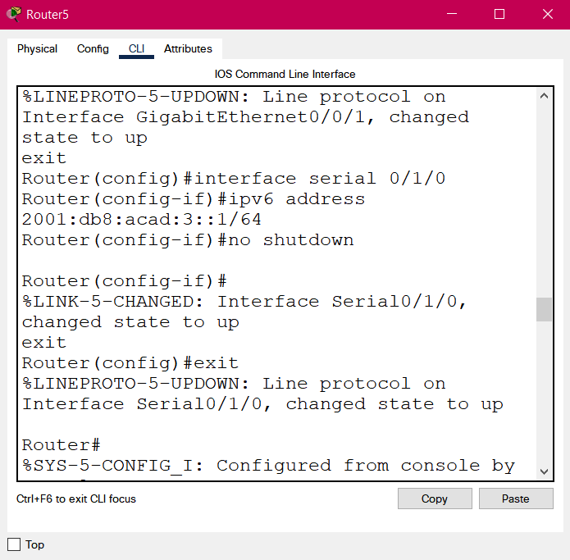

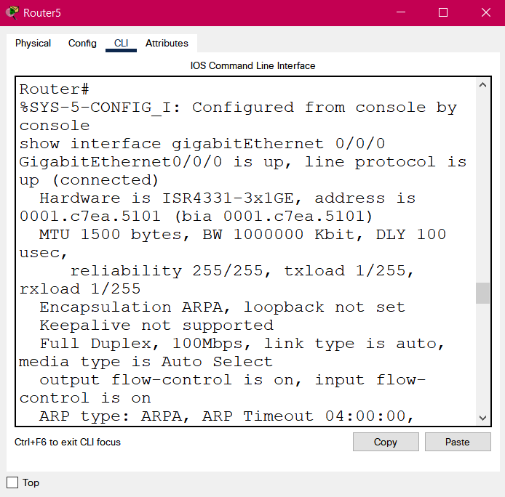

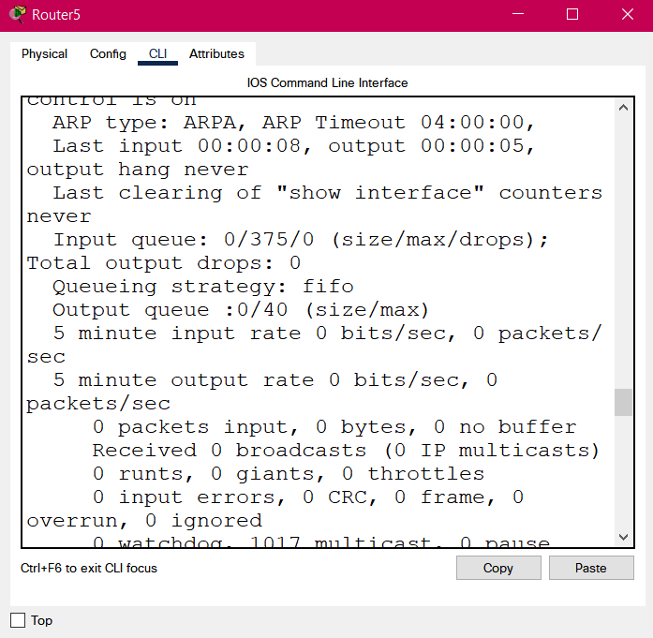

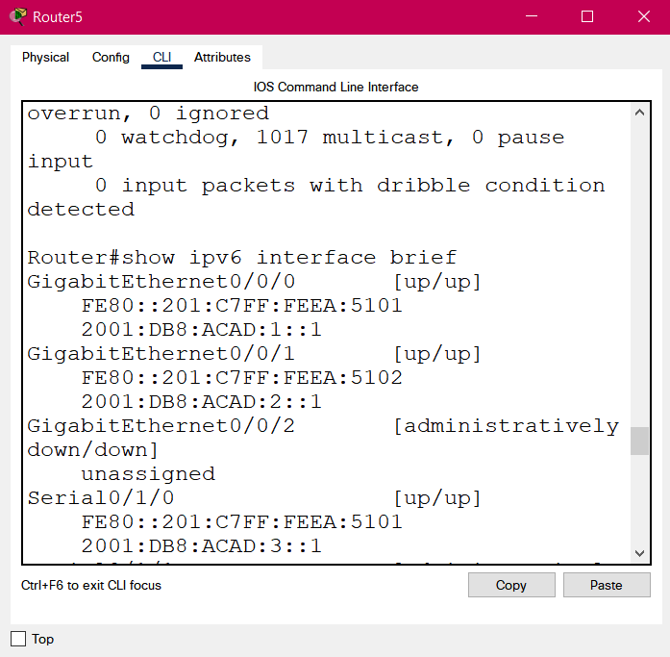

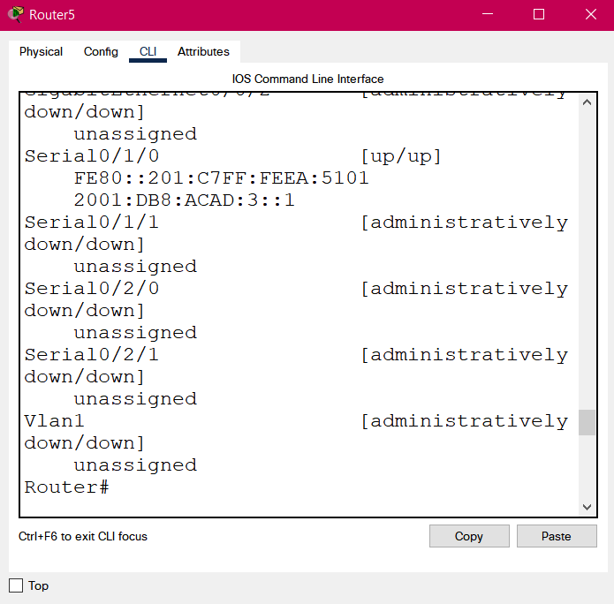

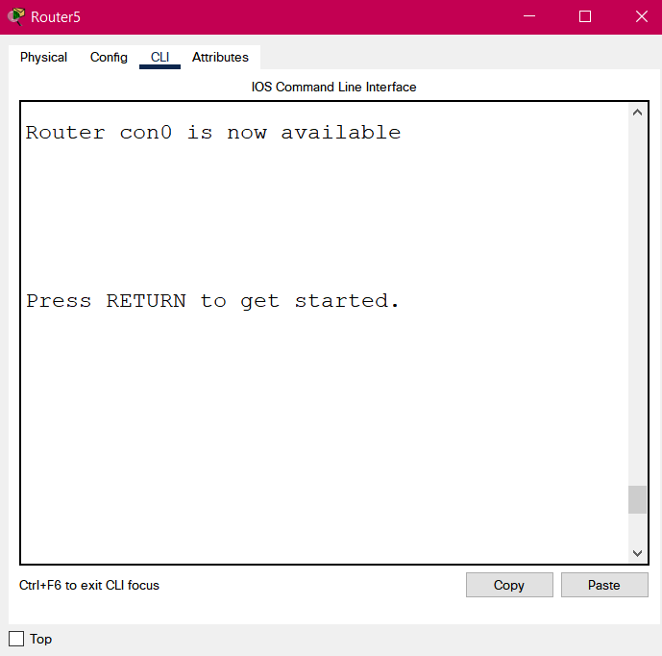

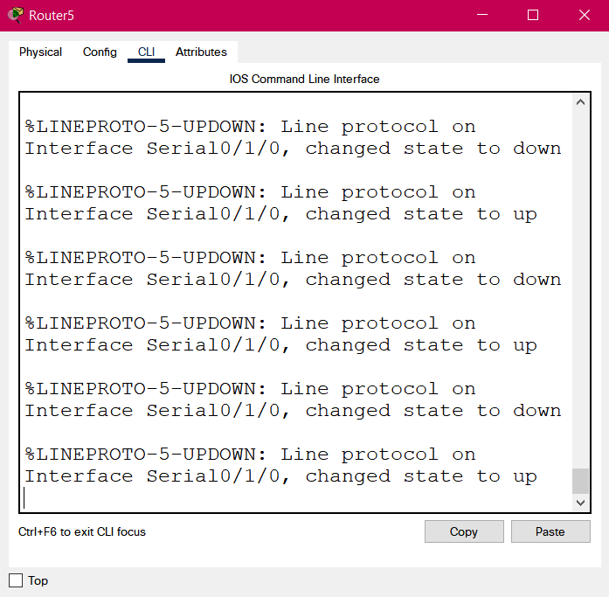

**Conclusion:** The experiment has been performed and all operations are correctly understood.

Experiment-9

**Aim:** To configure servers.

**Tools and Technologies Used:** Cisco Packet Tracer

**Theory:**

A server is a computer or system that provides resources, data, services, or programs to other computers, known as clients, over a network. In theory, whenever computers share resources with client machines, they are considered servers.

Following are some types of servers:

1. **DHCP:** A DHCP Server is a network server that automatically provides and assigns IP addresses, default gateways and other network parameters to client devices.
2. **DNS:** A DNS server is a computer server that contains a database of public IP addresses and their associated hostnames, and in most cases serves to resolve, or translate, those names to IP addresses as requested. DNS servers run special software and communicate with each other using special protocols.
3. **WEB:** A web server connects to the Internet and supports physical data interchange with other devices connected to the web.

**Practical:**

**Conclusion:** The experiment has been performed and all operations are correctly understood.

Experiment-10

**Aim:** To perform static routing with ipv6 route command.

**Tools and Technologies Used:** Cisco Packet Tracer

**Theory:**

Static routing is a routing type in which a network administrator configures the routes into the routing table to be used by the router to send packets to a destination network. A static IP route specifies the route's destination address and the next-hop router's IP address or routing switch interface through which the routing switch can reach the destination.

Following are the commands which are used while static routing with ipv6 route command:

1. **en:** Enable command to go from use execution mode to privileged execution mode.
2. **conf t:** To move to configuration mode.
3. **interface:** To select a particular interface and connect it.
4. **ip address:** To assign an ipv4 address.
5. **interface serial:** Serial ports are used to connect routers together and the Gig/FA ports on the router connect it to a switch.
6. **no shut:** no shutdown turns the interface on (enables it).
7. **show ip interface brief:** To show a summary of configuration.
8. **exit:** To exit a configuration mode.

**Practical:**

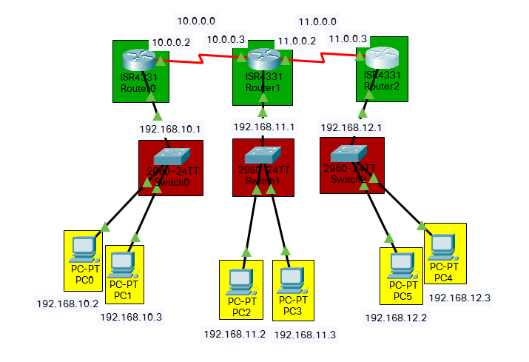

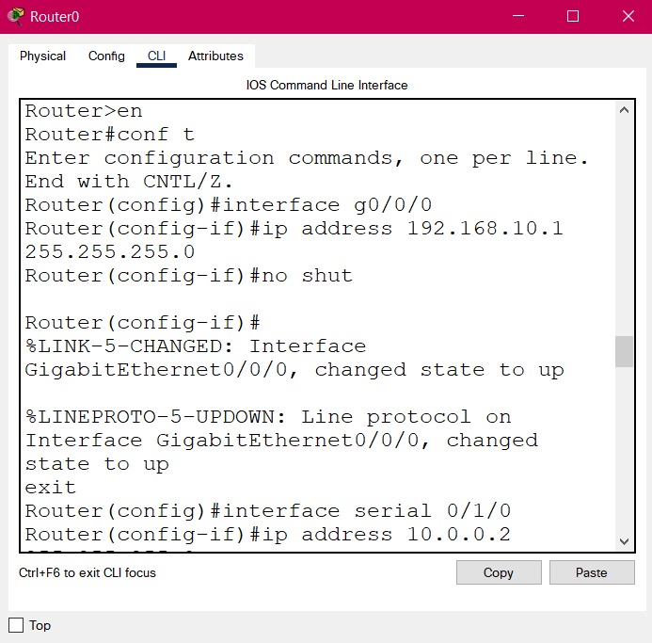

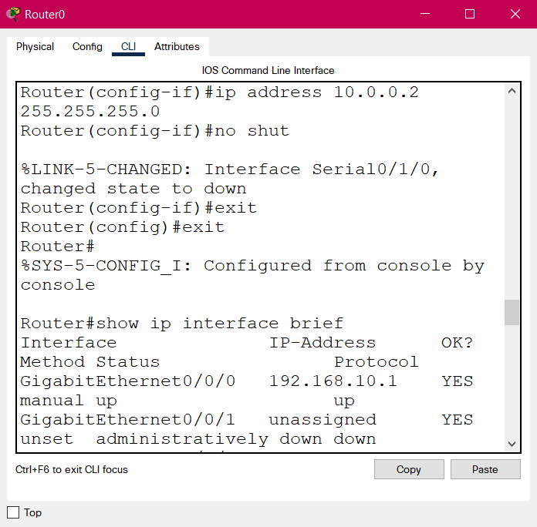

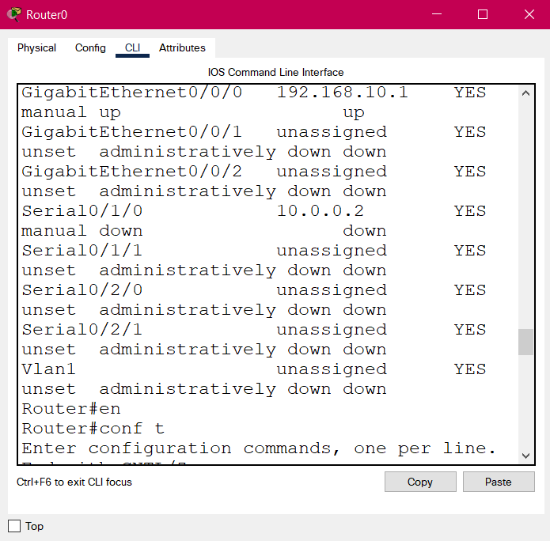

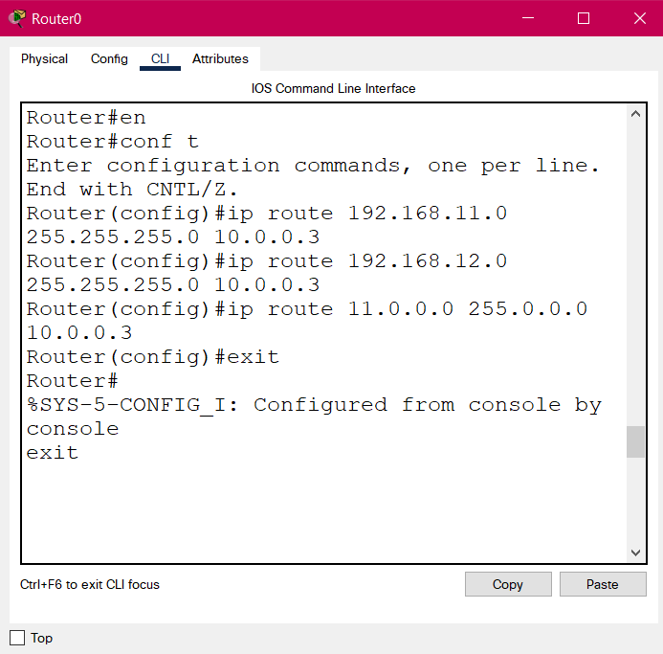

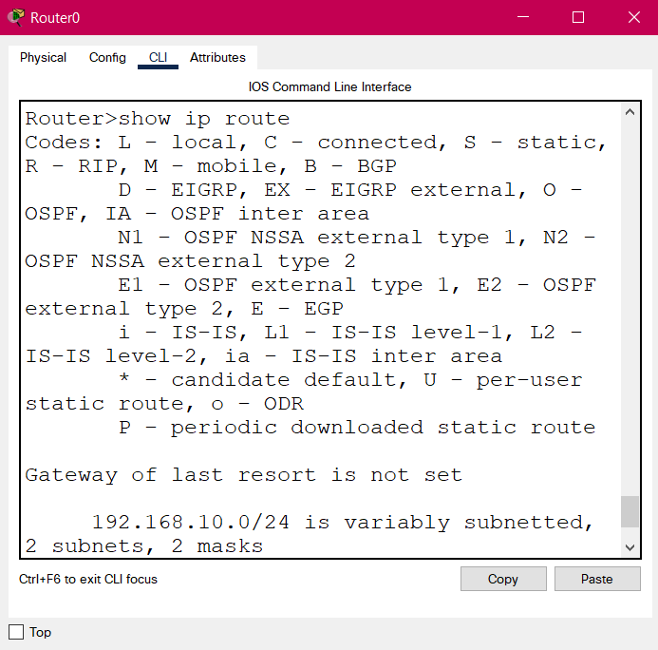

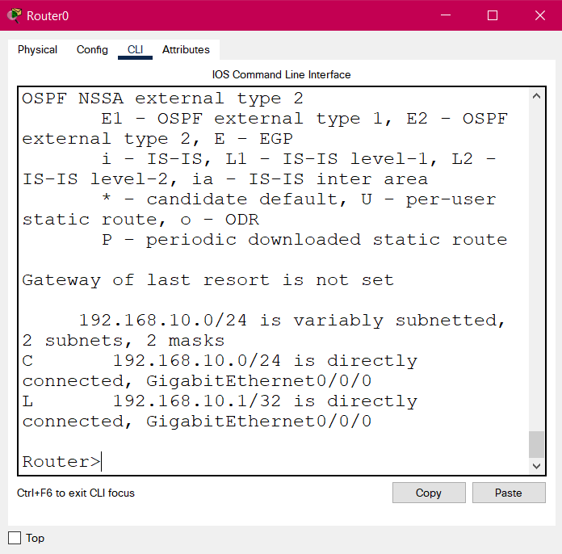

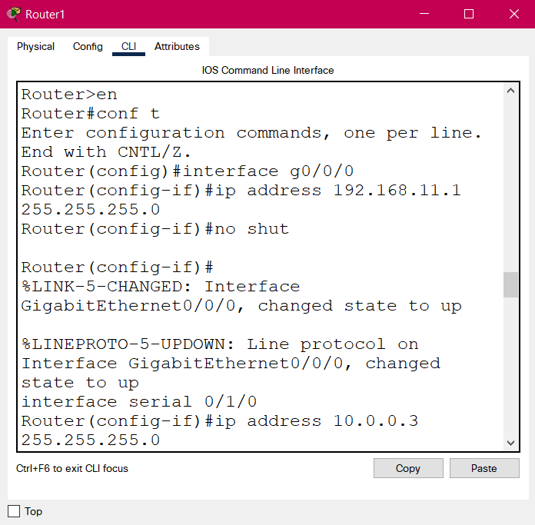

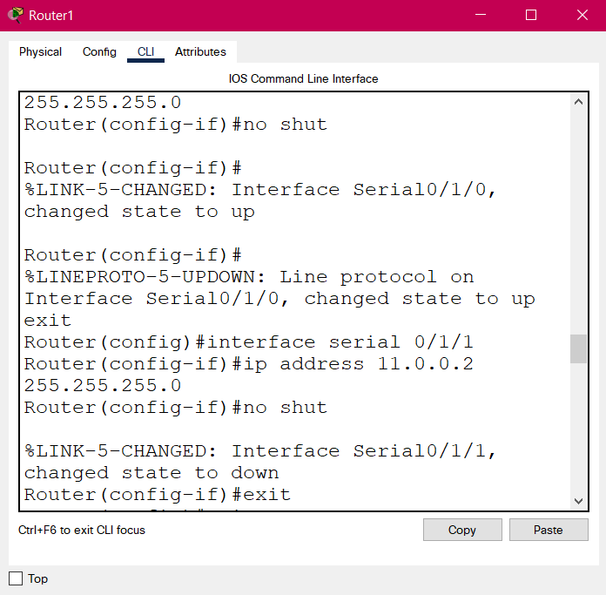

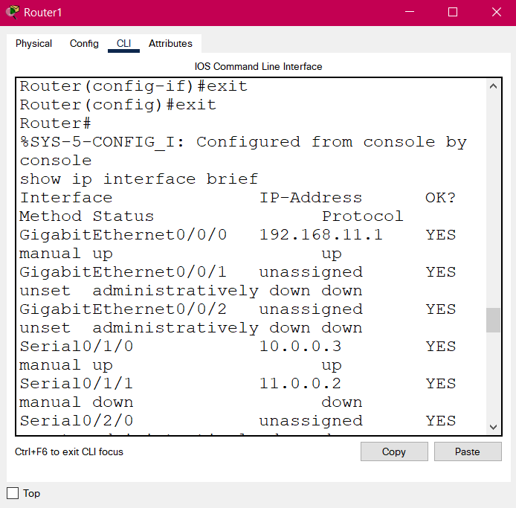

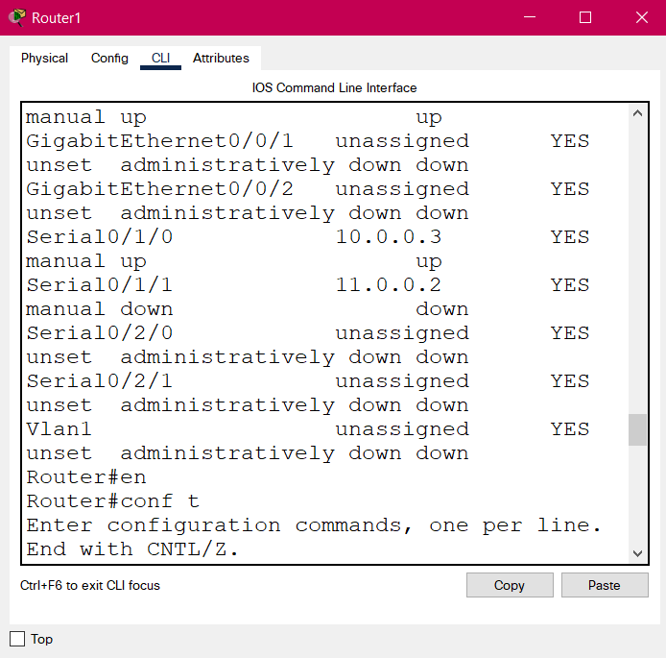

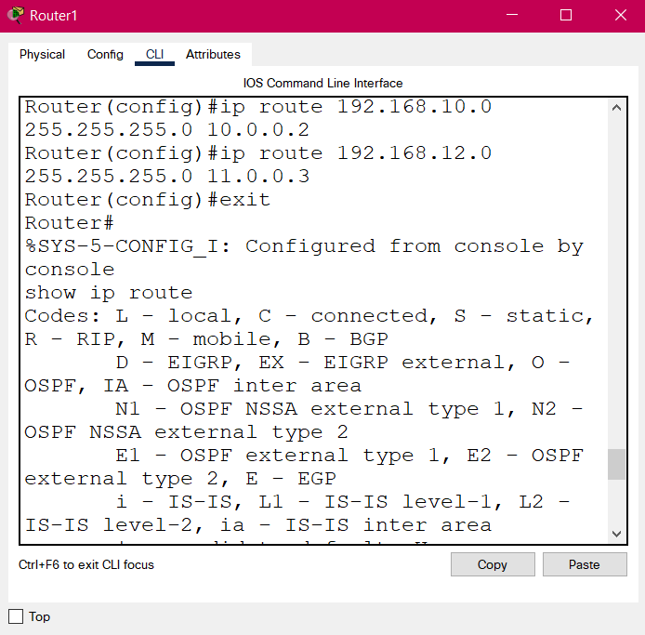

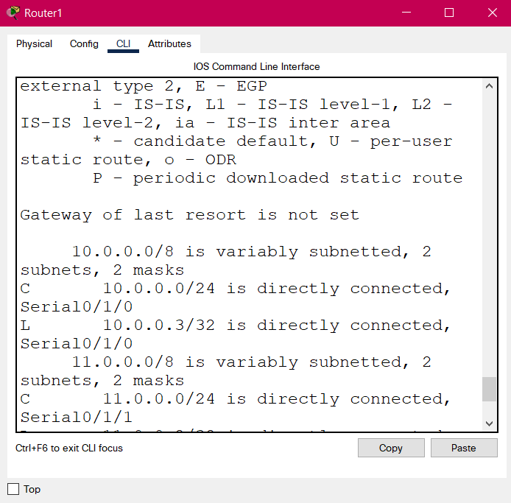

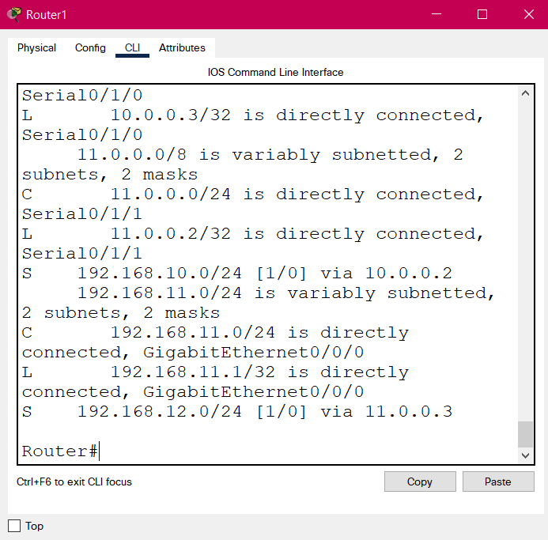

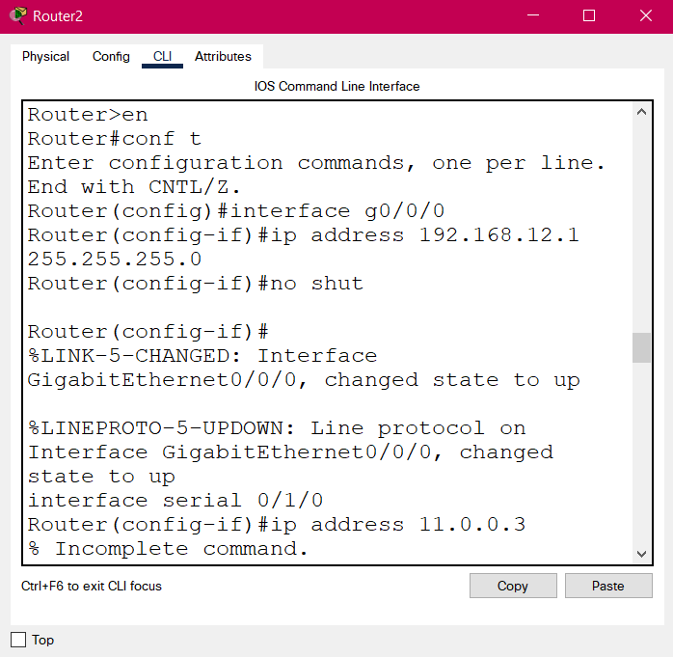

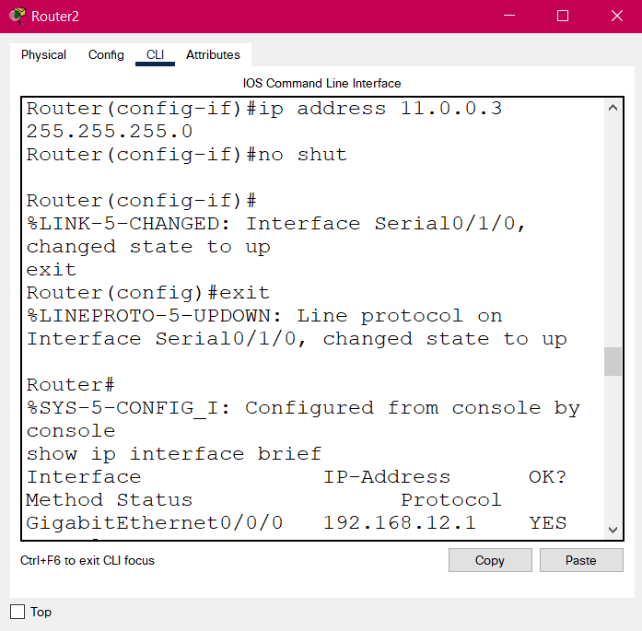

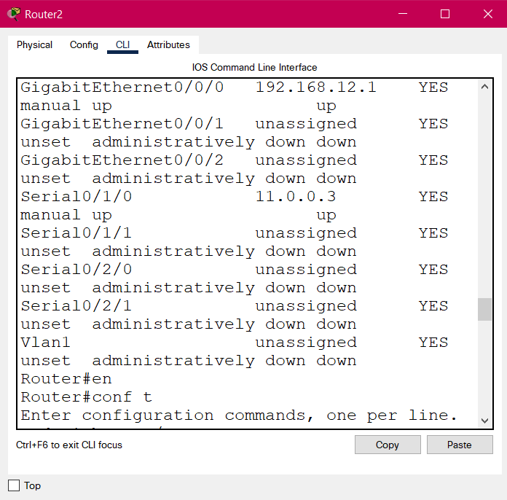

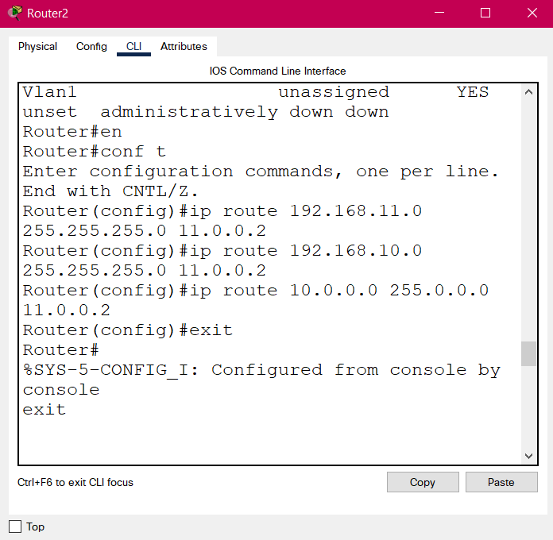

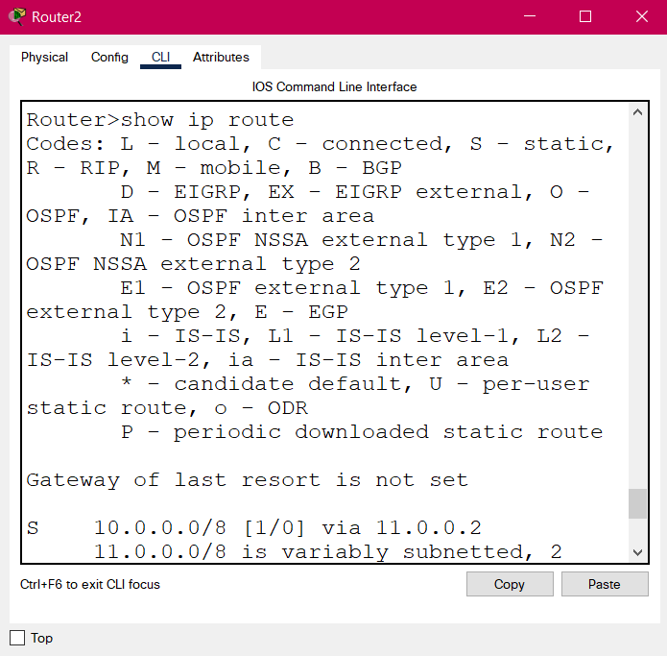

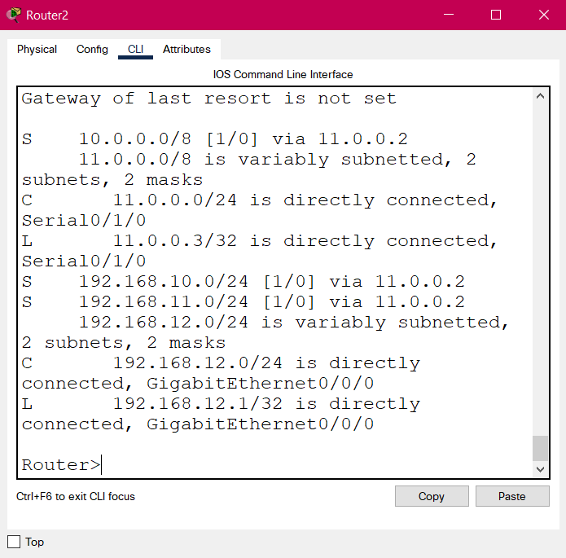

**Conclusion:** The experiment has been performed and all operations are correctly understood.